**Name: Mriganka Patra**

**Email:** [**mriganka.patra@cognizant.com**](mailto:mriganka.patra@cognizant.com)

**Emp ID: 2415820**

**Day 18**

**Sprint 1 Submission**

**Objective: Implement the base CRM logic with record types, automation, visibility settings, and user management.**

Task 1.1: As an admin I want to define record types for Accounts based on regions so that data can be segmented accordingly.

a. Go to Setup >

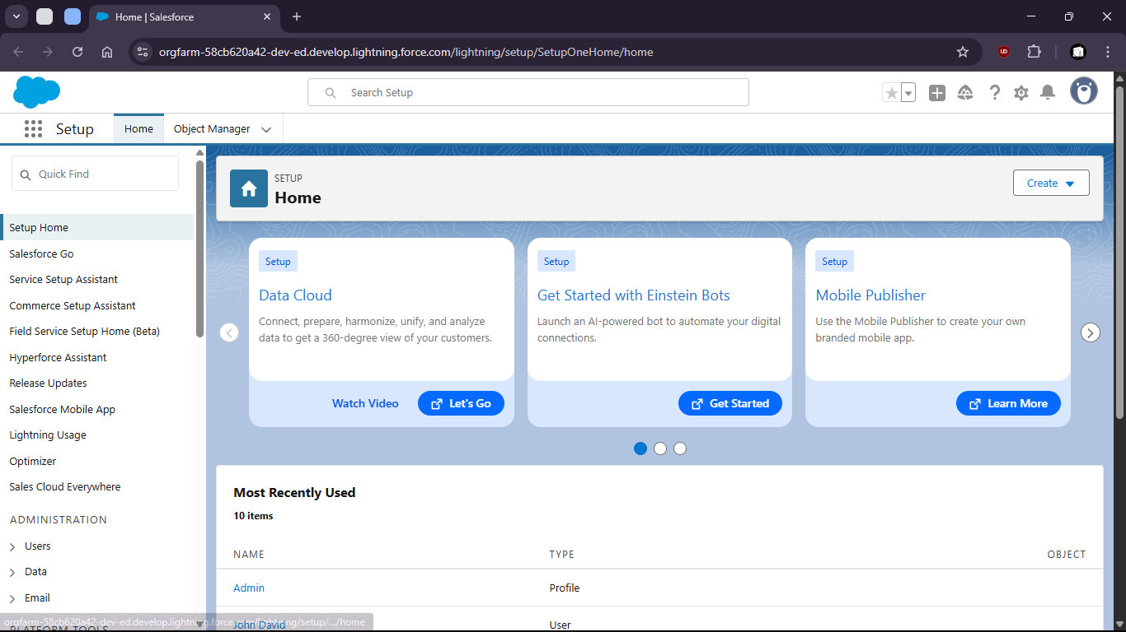

b. go to Object Manager

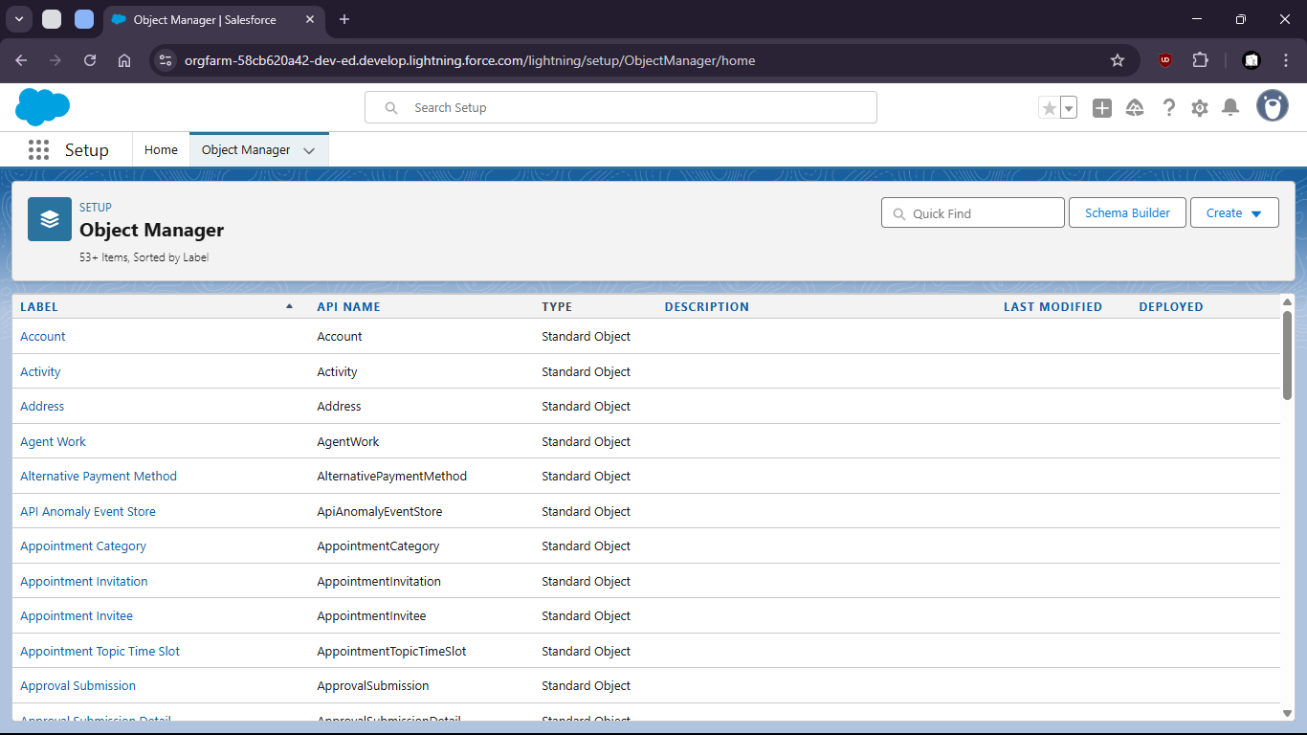

c. Select Account object

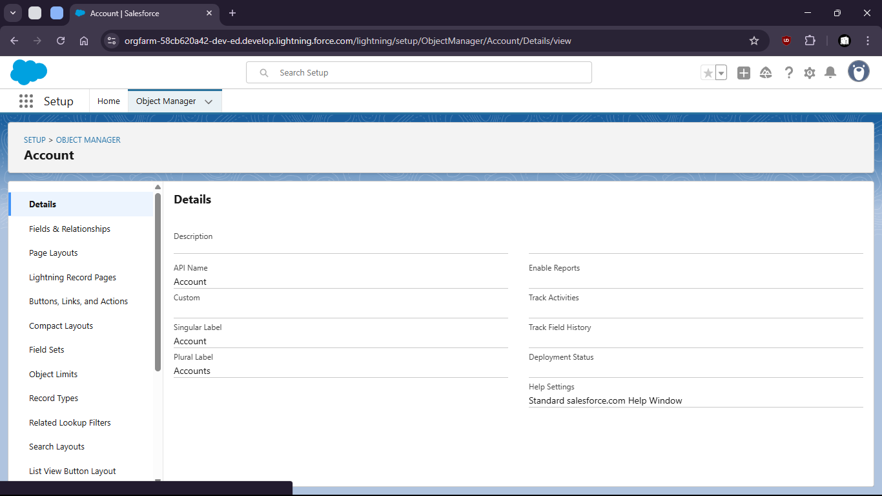

d. select Record Types

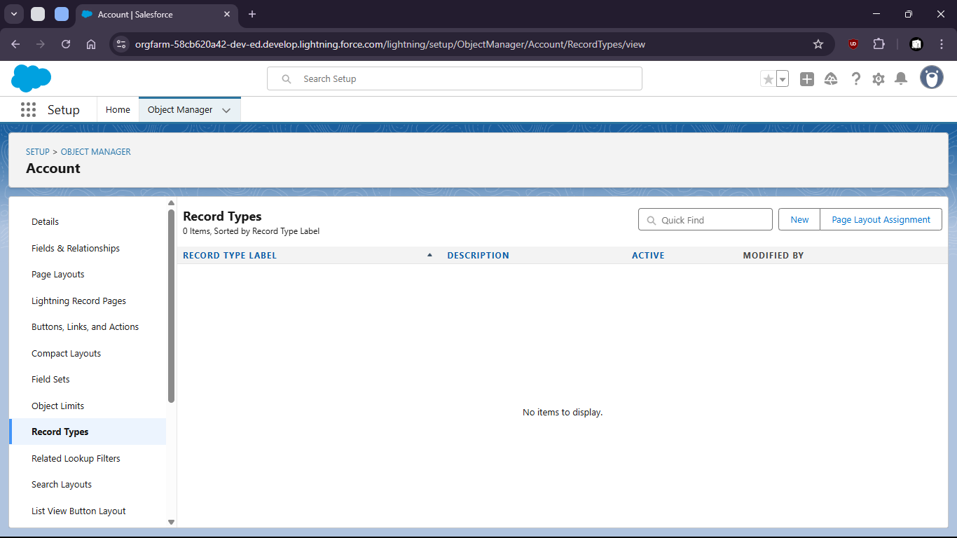

e. create new Record Type for Kolkata people and give permission to admin

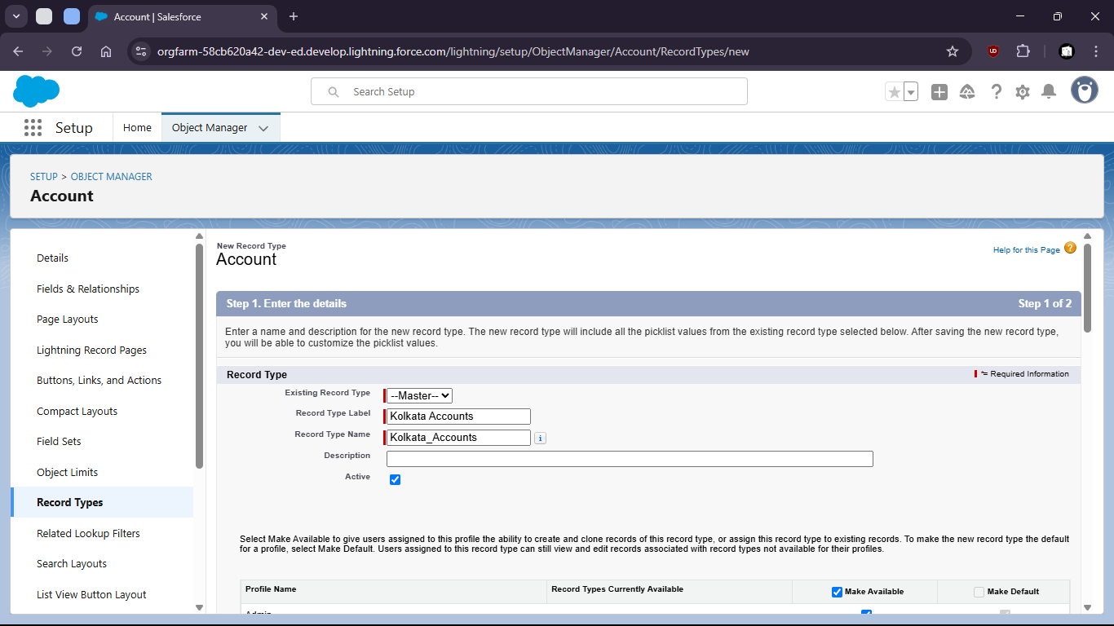

f. give permission

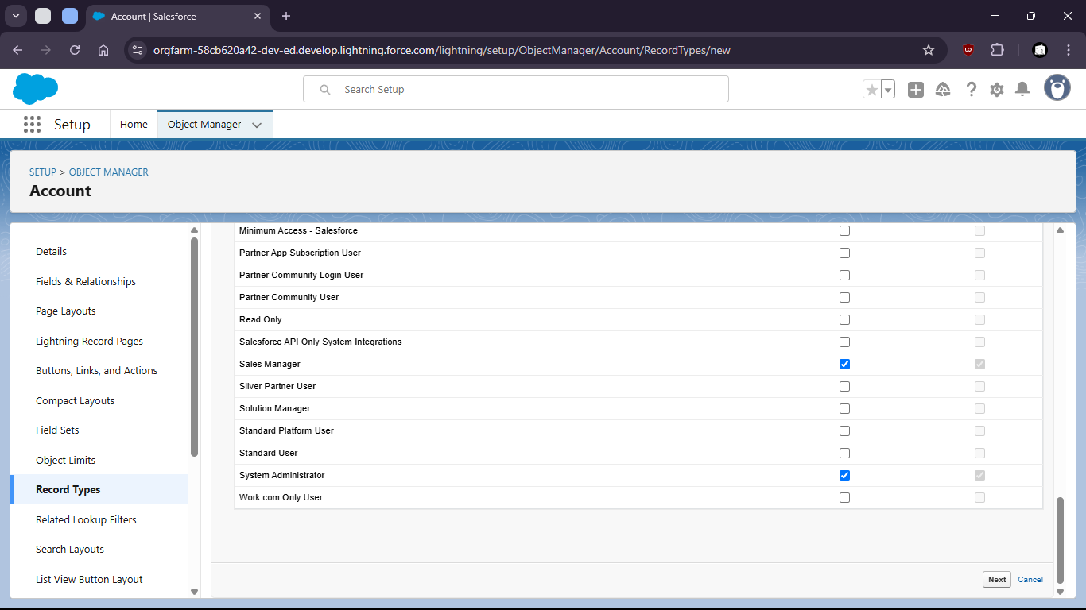

g. set page layout

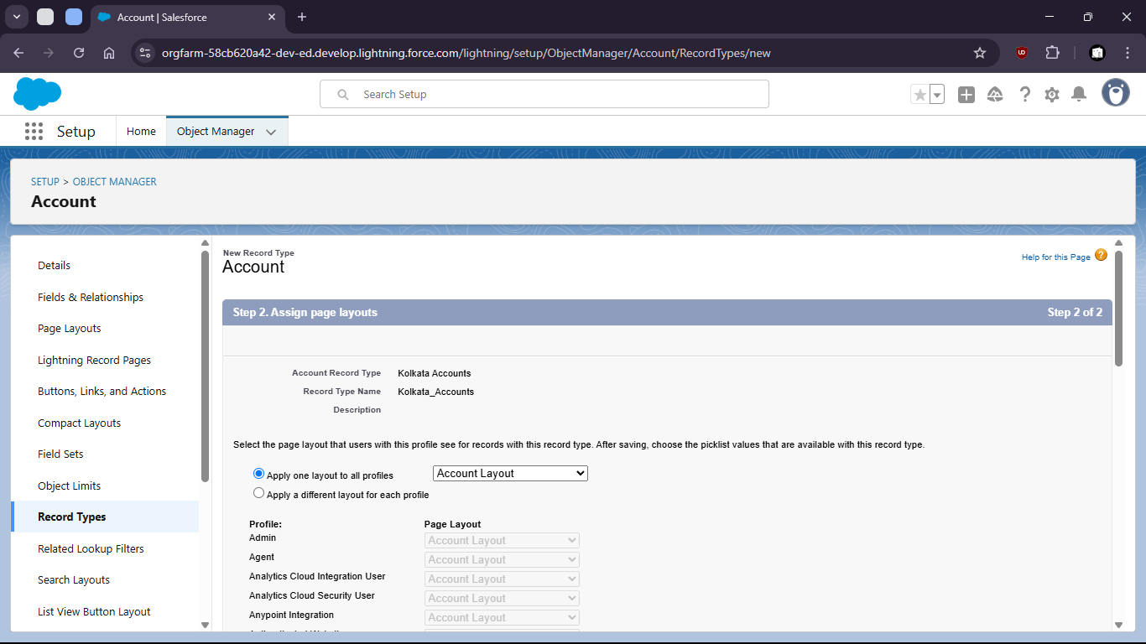

h. Select save and new

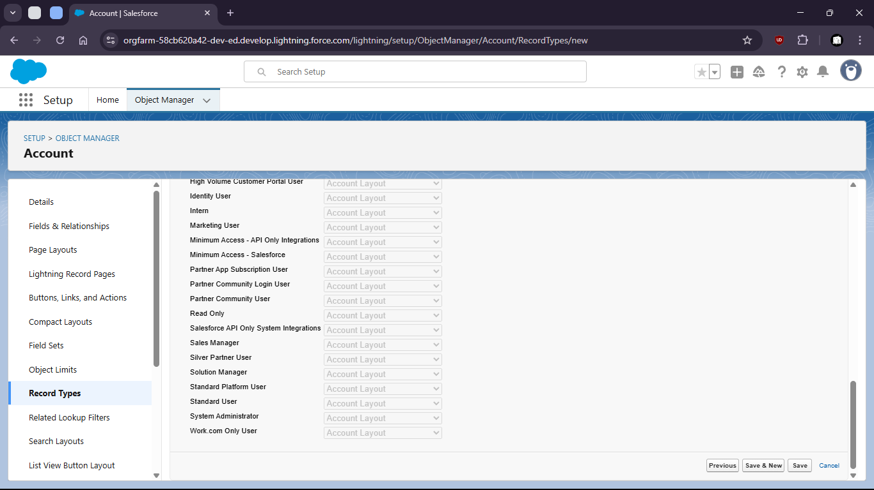

i. create another for Delhi region

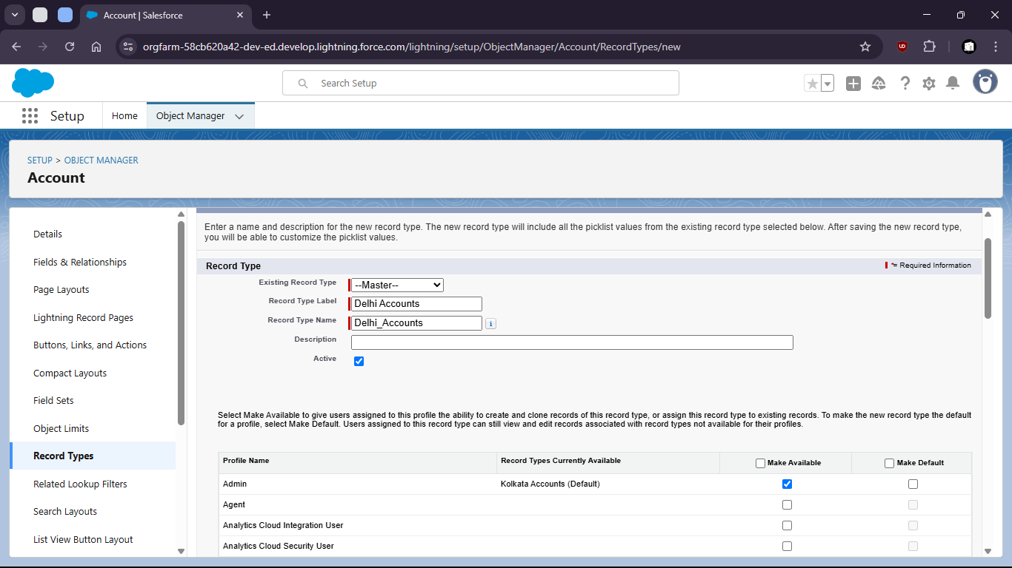

j. Give permissions to profiles

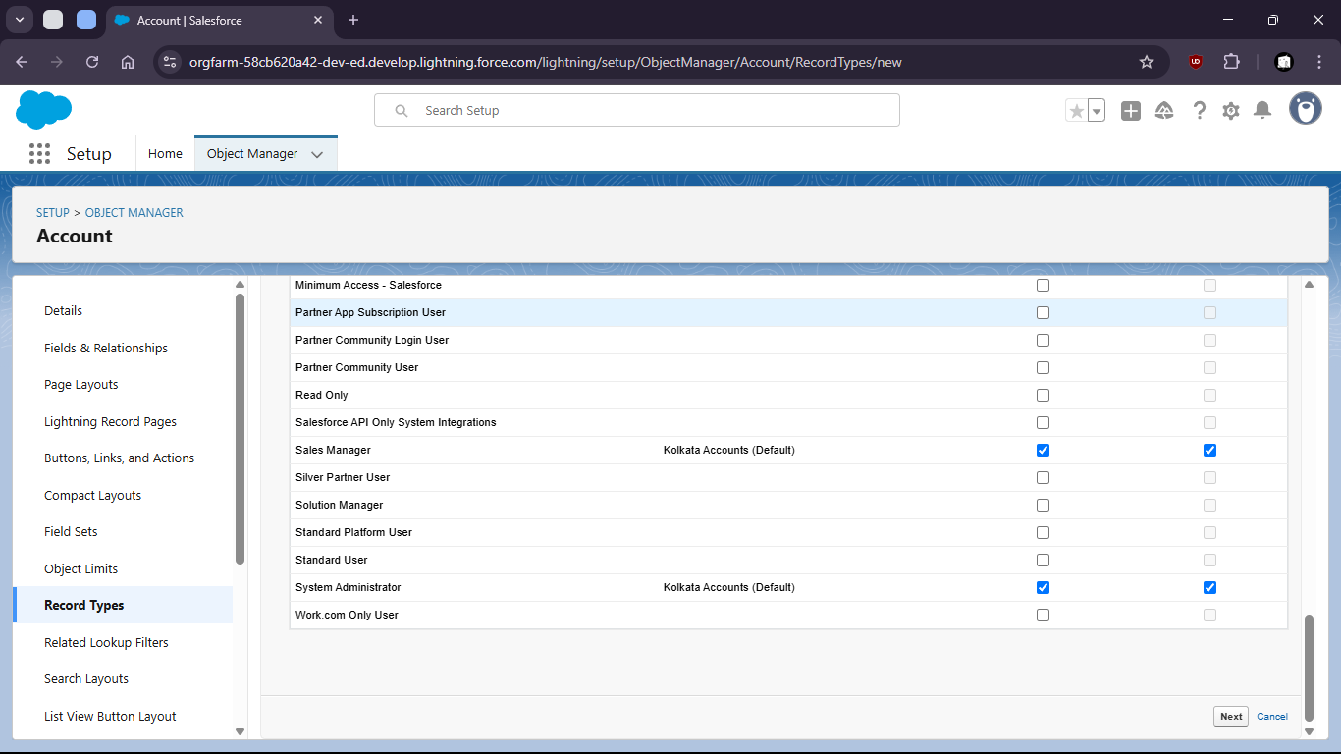

k. Set layout

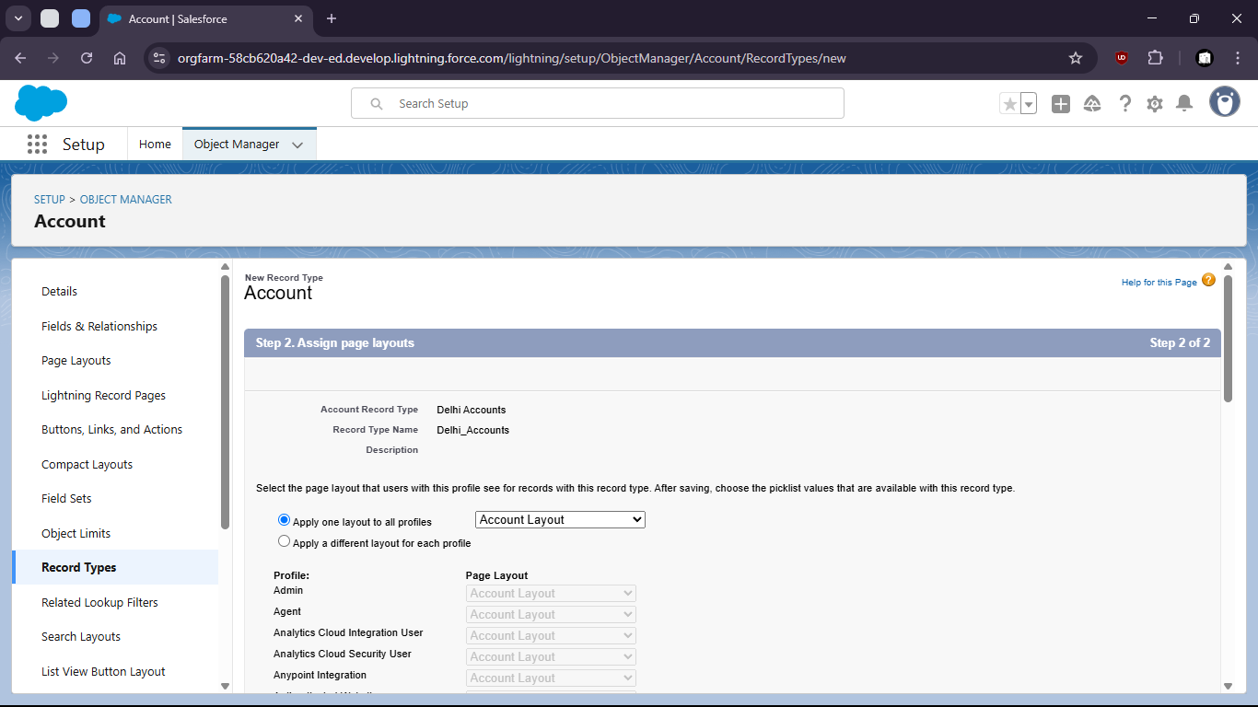

l. Save



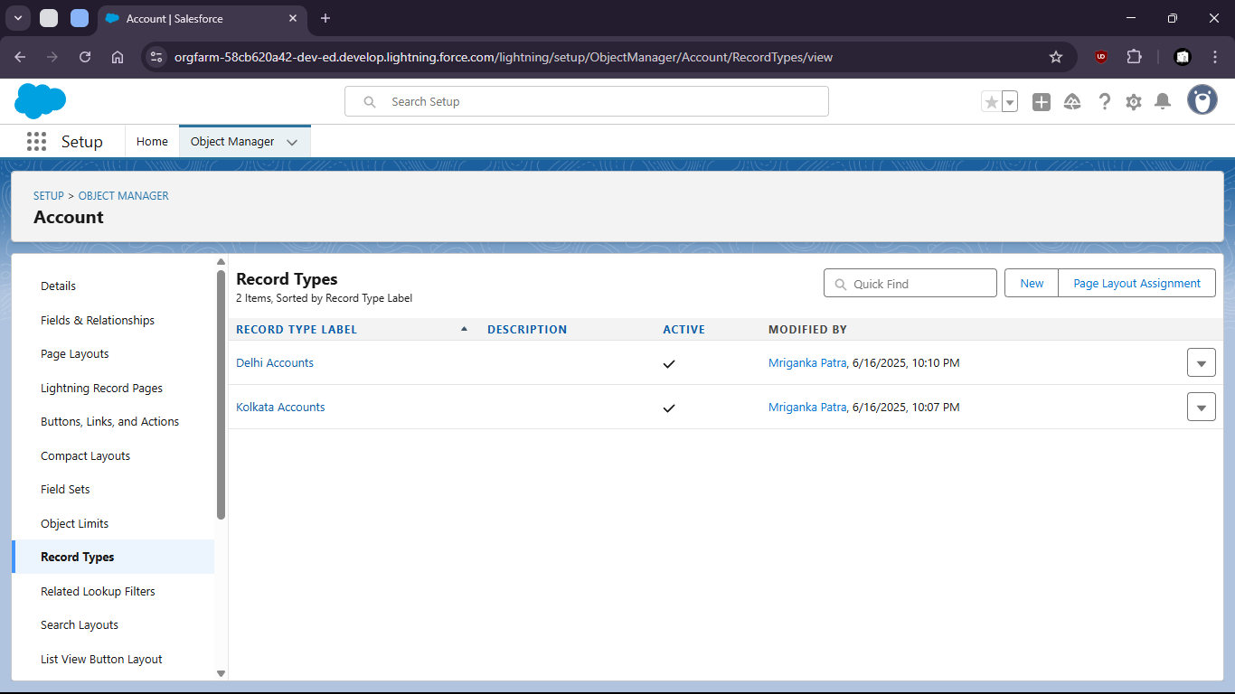

Task 1.2: As a CRM user, I want to see the age of a contact calculated from their birthday so that I can segment users by age group.

1. Go to object Manager
3. 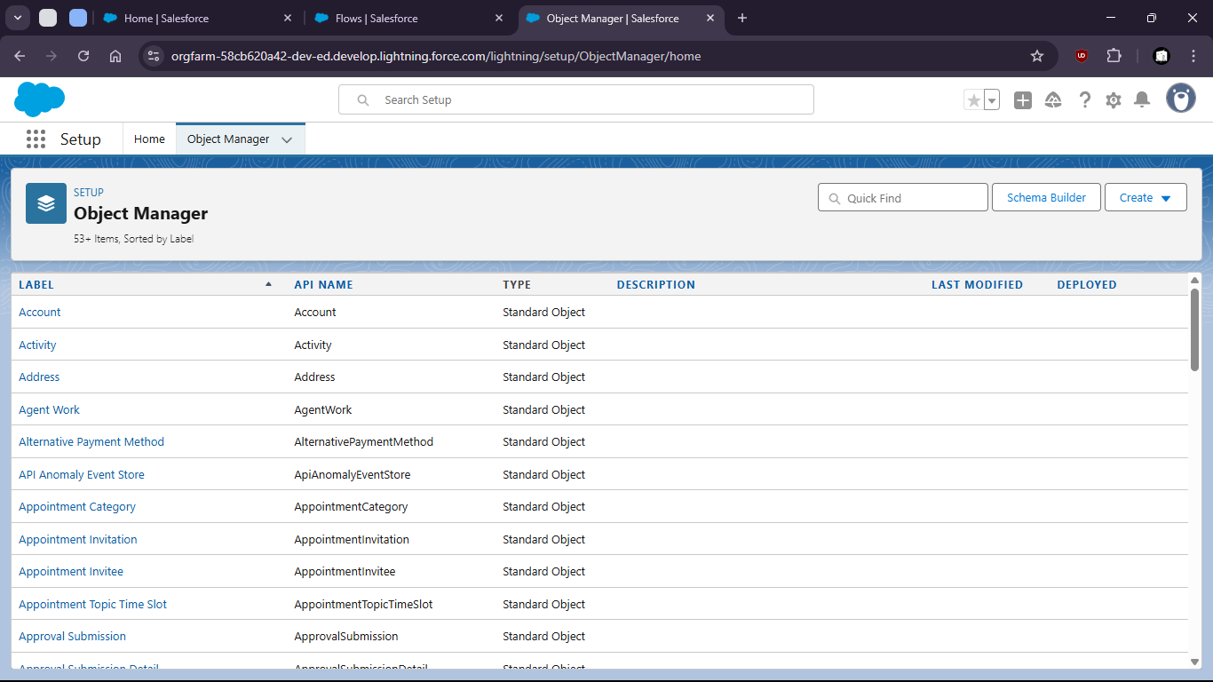
5. Select Contact object
7. 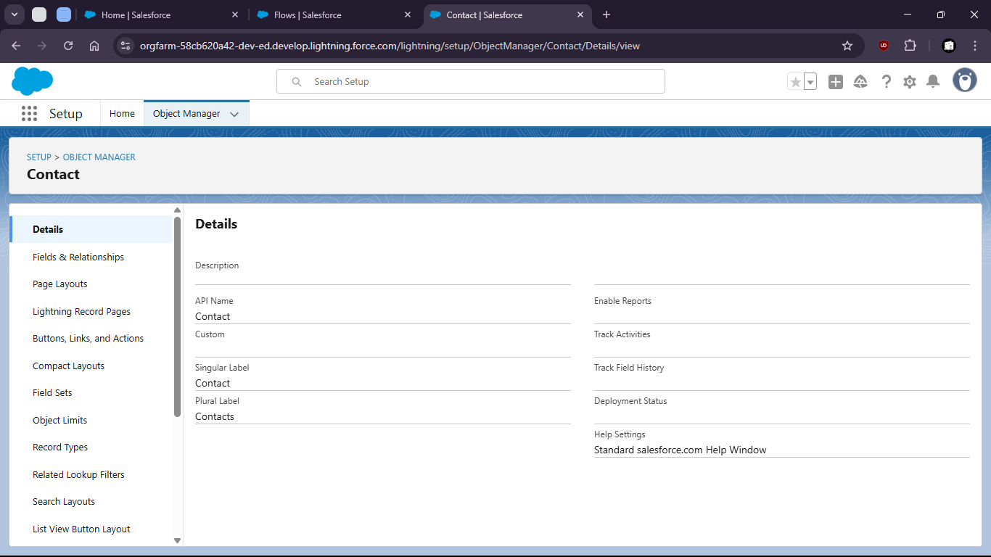
9. Go to the fields and relationships
11. 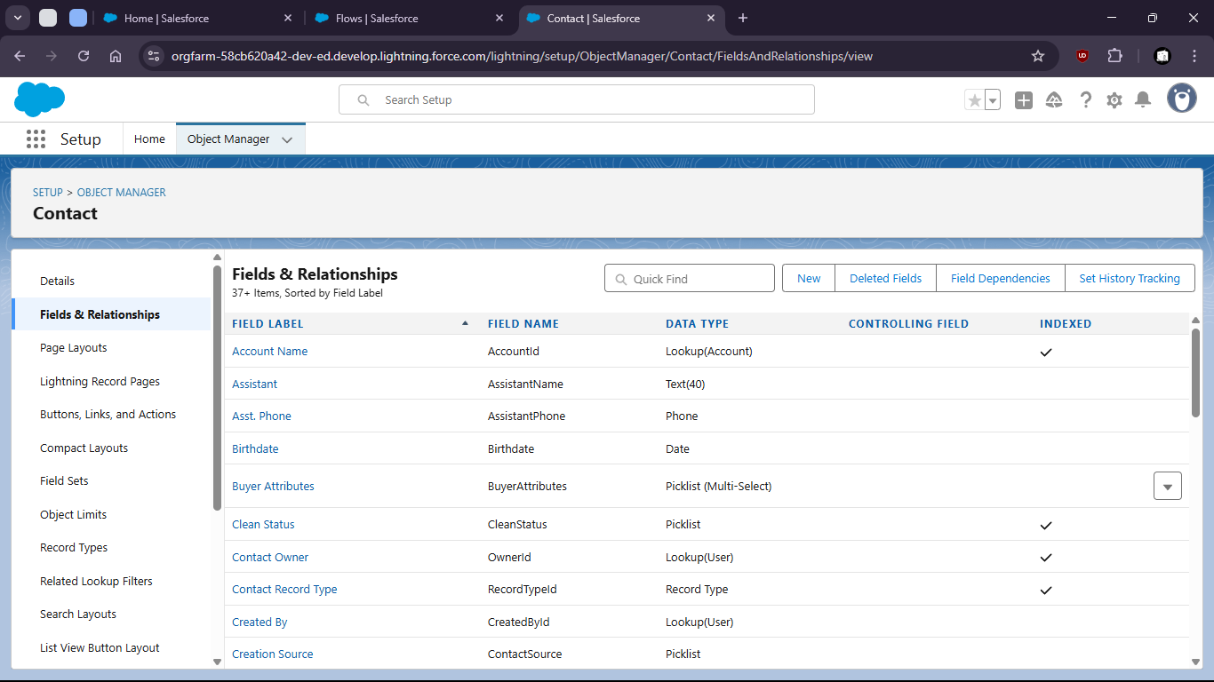
12. Create a new Field as Formula
14. 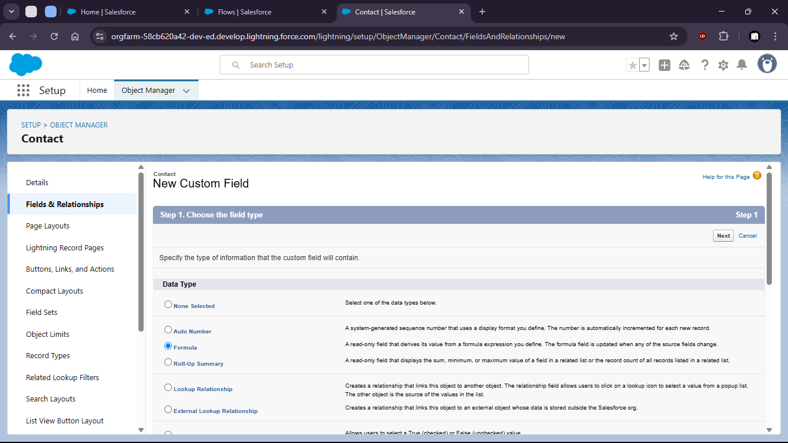
16. Give name and type
18. 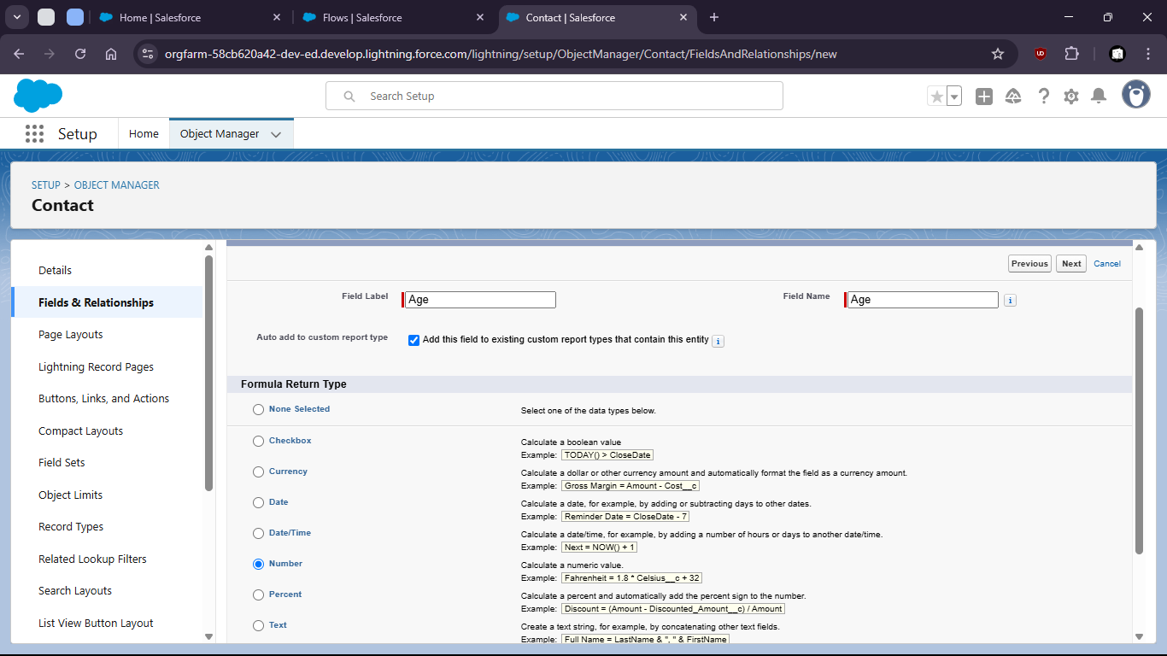
20. Enter the formula with proper syntax
22. 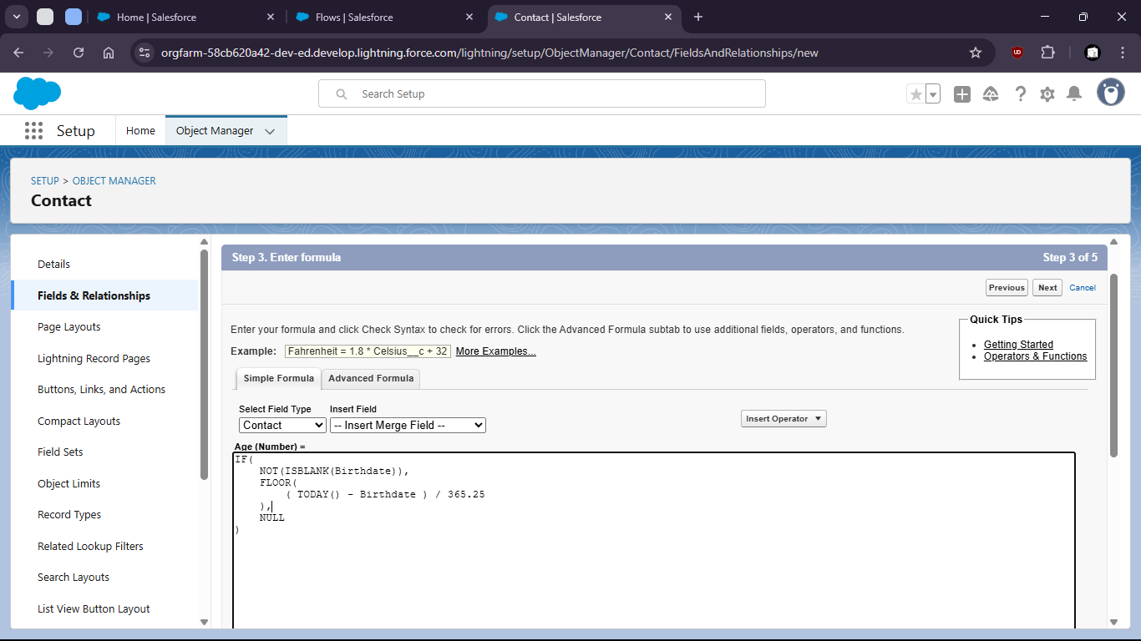
24. Setup field level security and save
26. 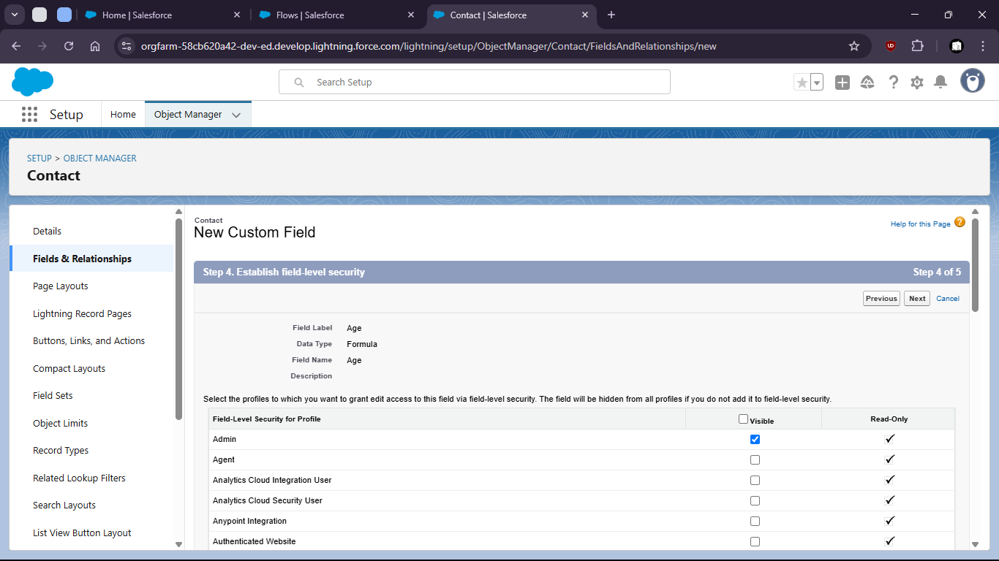
28. 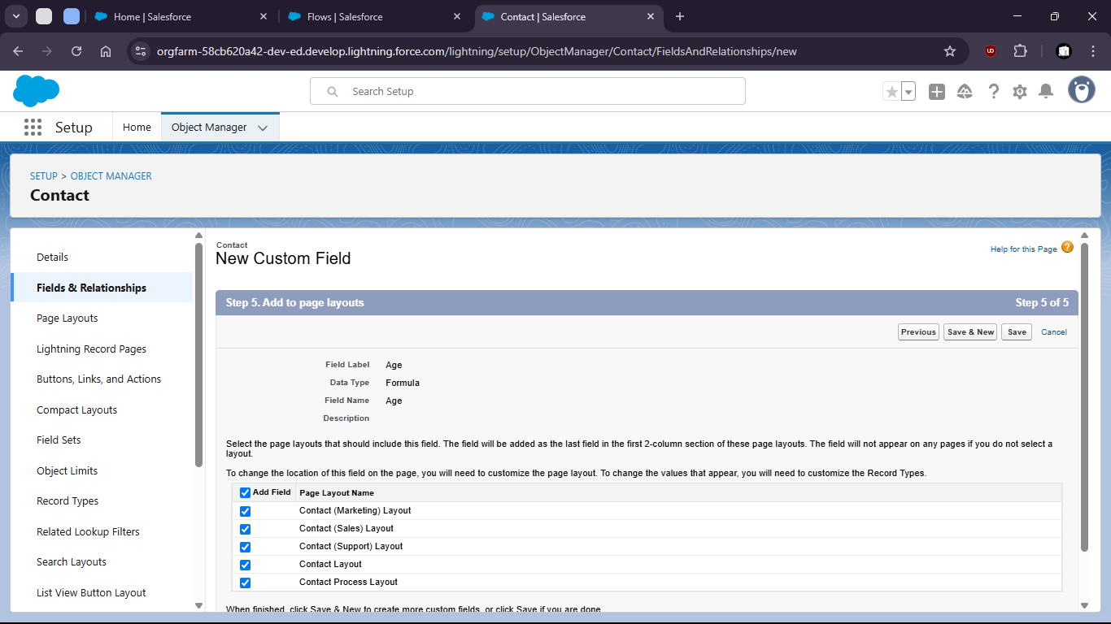
30. 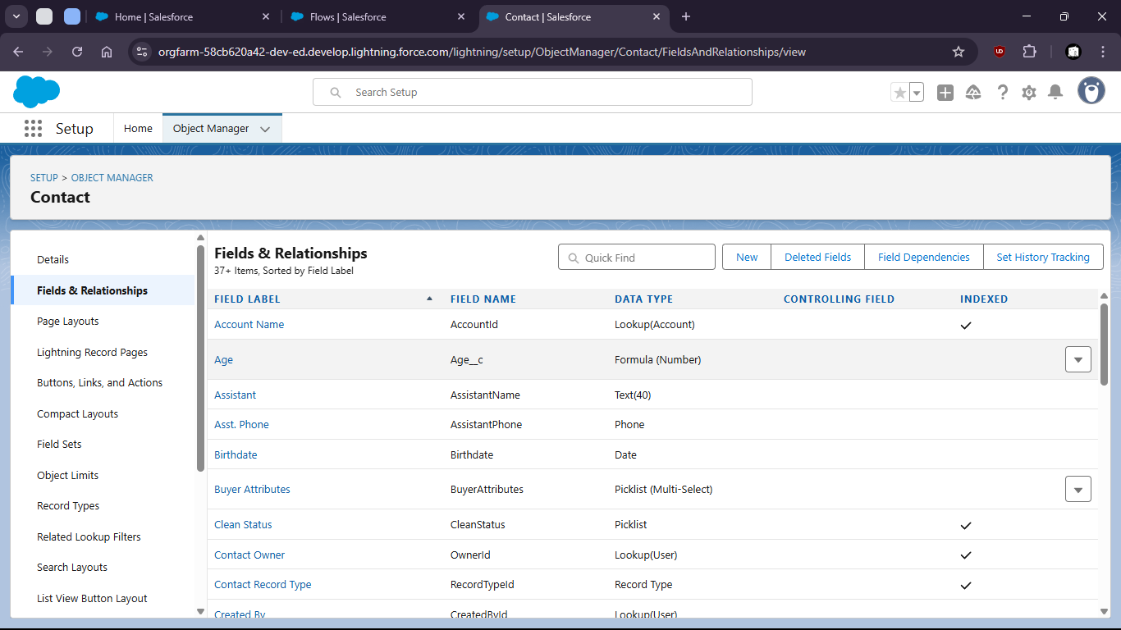
32. Now verify the field is working or not.
34. Go to contacts > create new contacts
36. 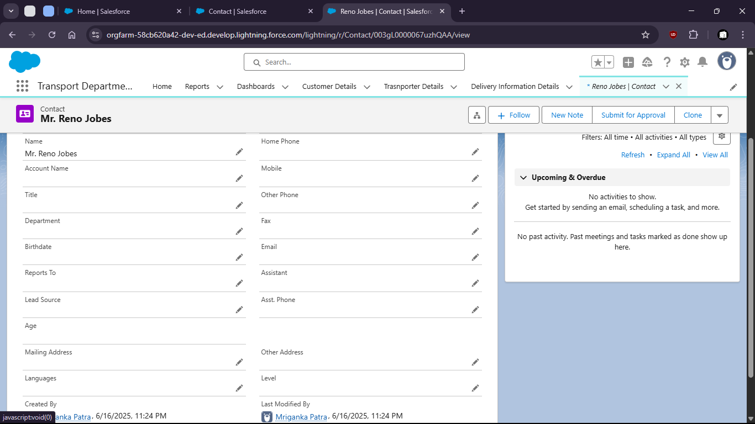
37. When no Birthdate given the age shows empty (NULL)
39. But when we put a Birthdate the age is calculated
41. 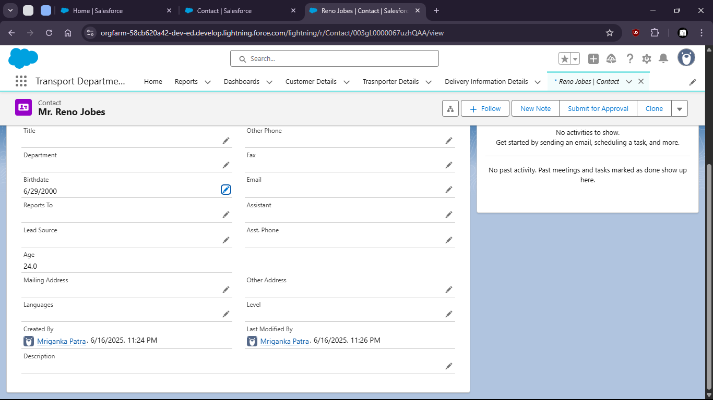

Task 1.3: As an admin, I want to create Users with specific access levels so that only autorized roles can access or edit data.

1. Goto setup > home
3. 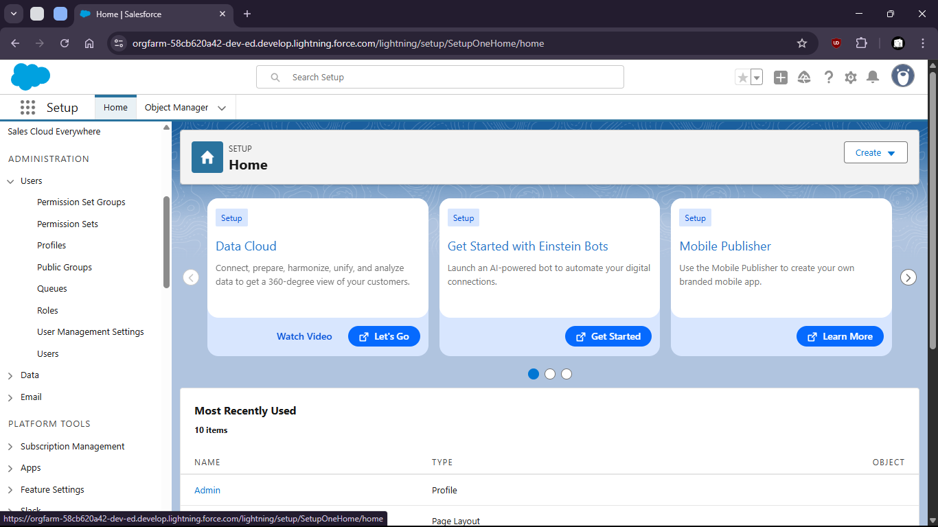
5. Open profiles and create profiles
7. 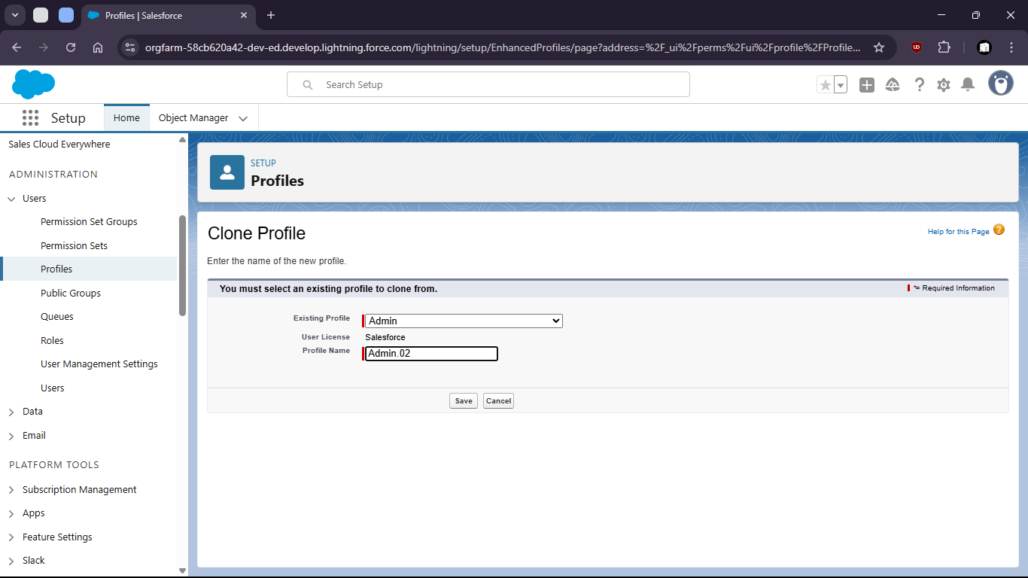

10. Limit Access (field level security)
12. 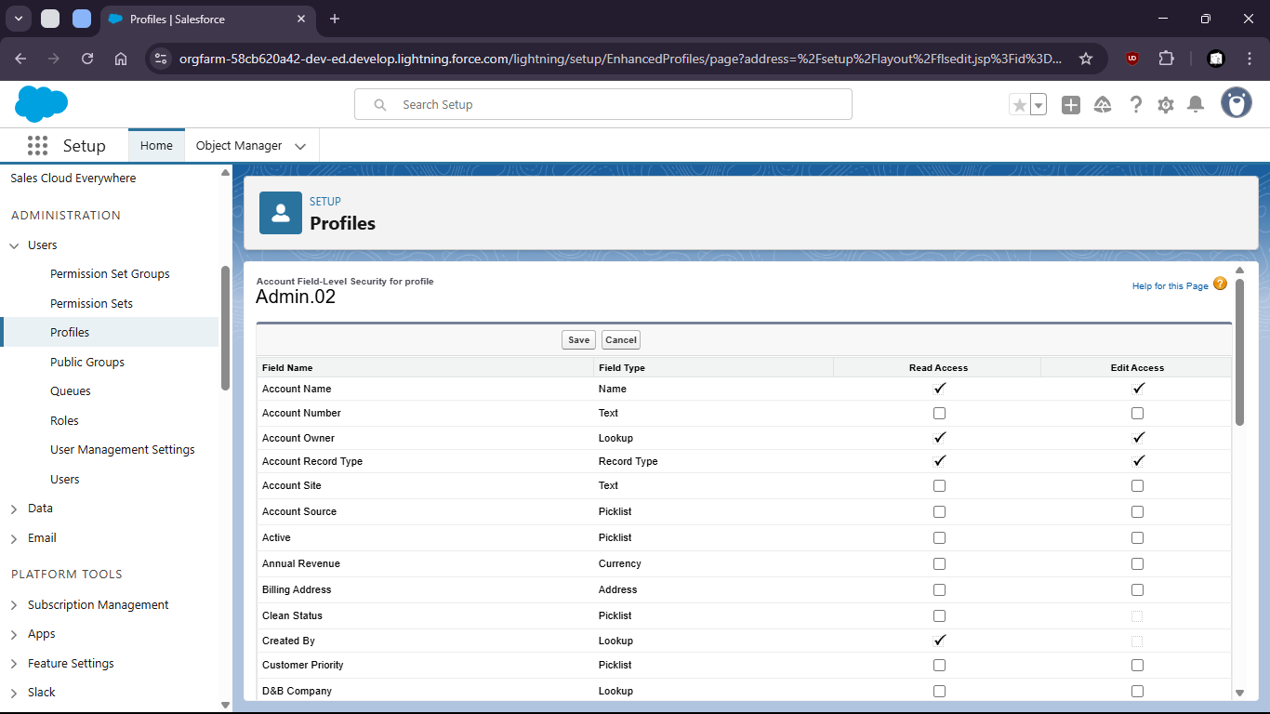
13. Set standard object Permissions
15. 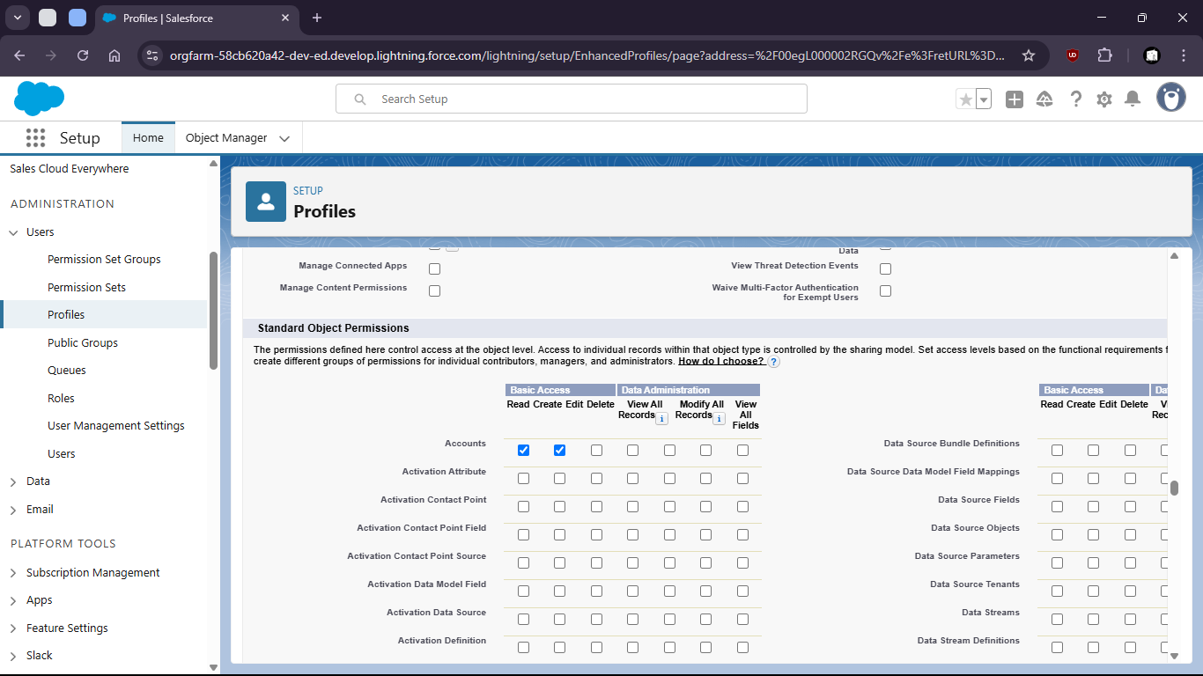
17. Add to permission sets
19. 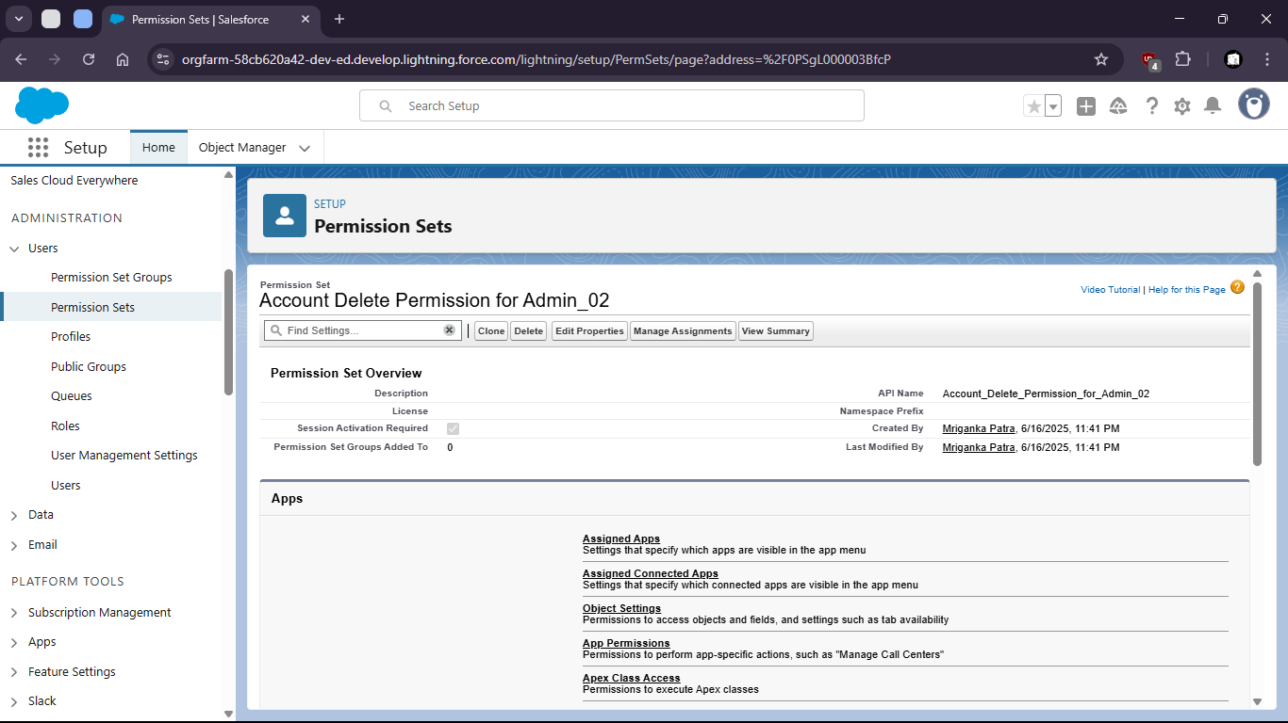
20. Change object settings
22. 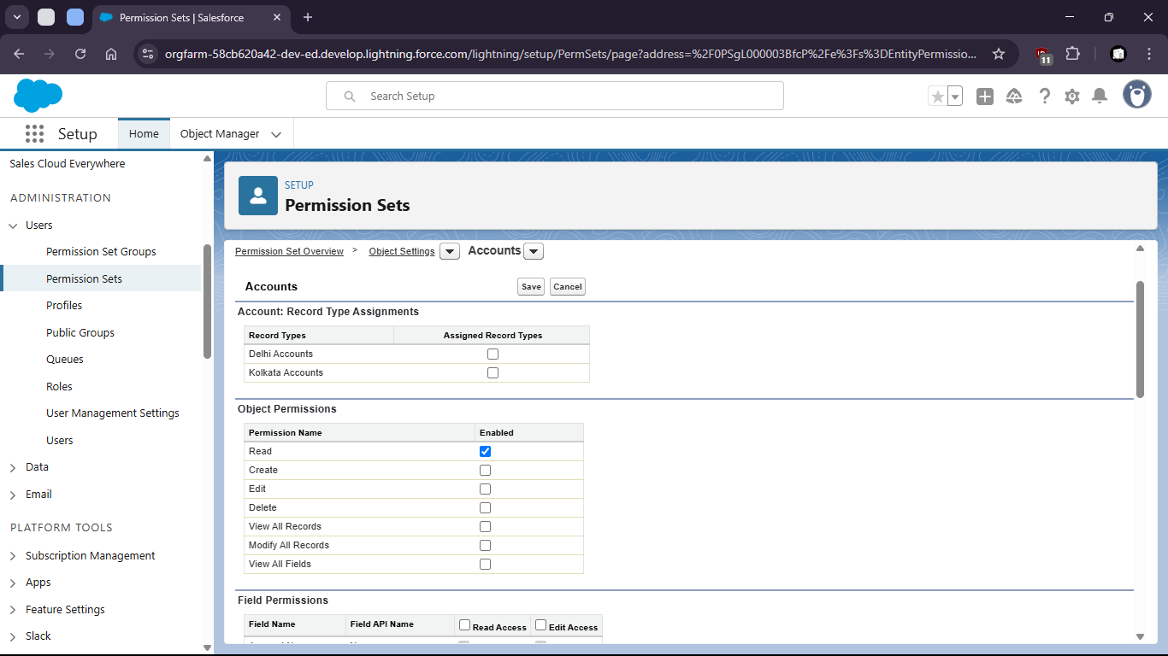
23. Create new User
25. 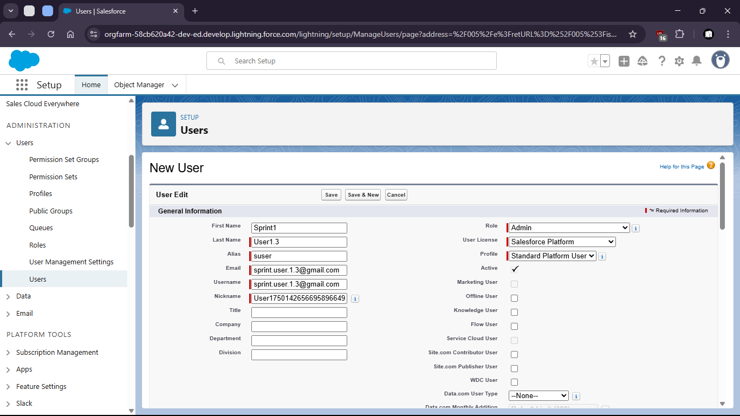
26. Assign user to Permission sets
28. Assigning User to Roles can also limit access levels
30. 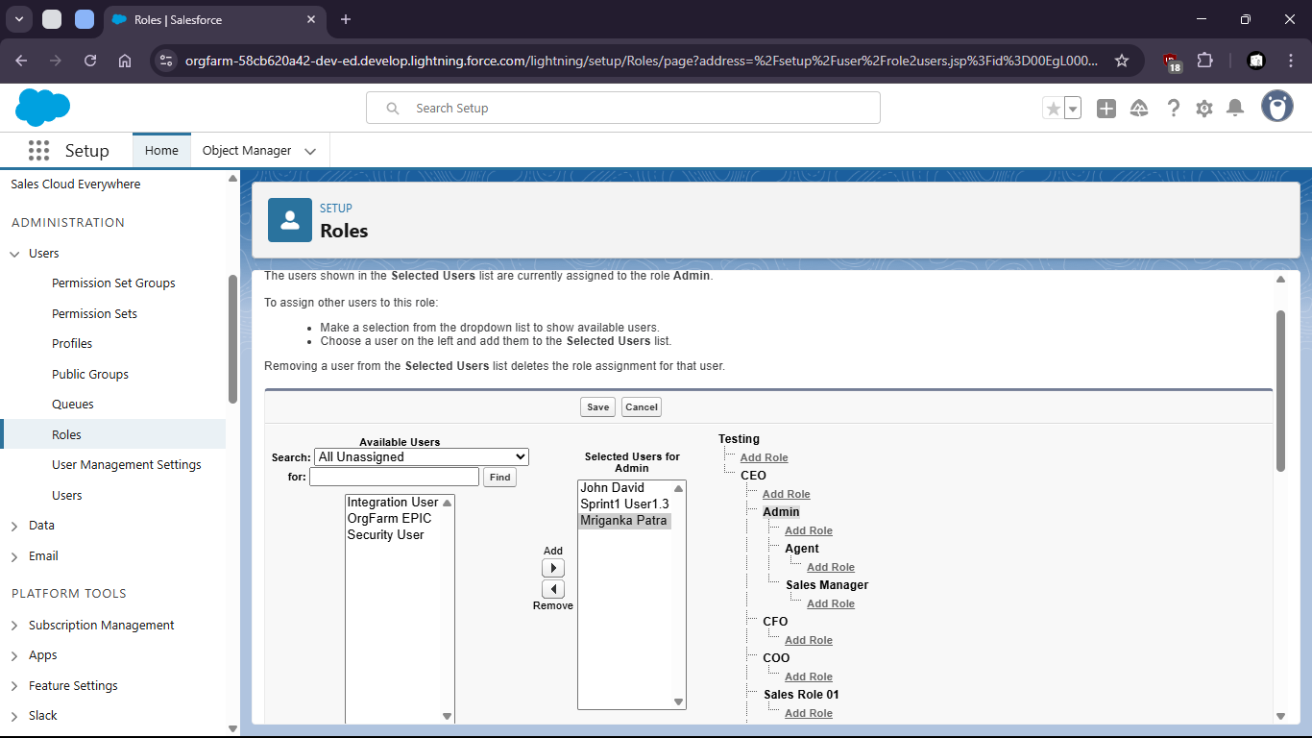
31. Where the access is restricted to upper levels

Task 1.4: As an admin I want to set visibility rules for data so that users only see records relevant to their role.

1. Go to setup > home
2. Search for sharing settings
4. 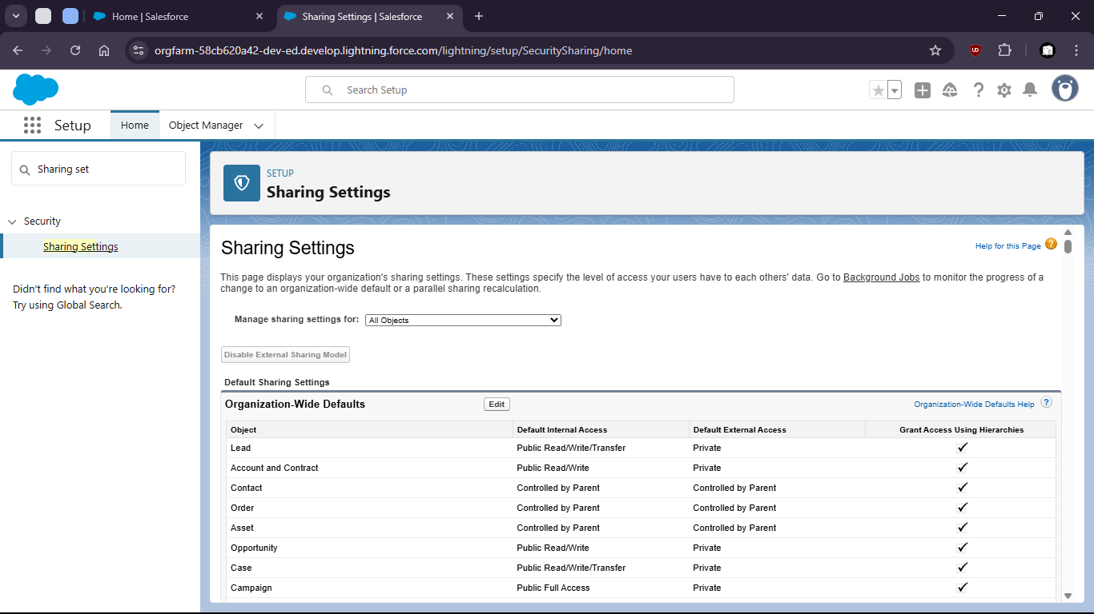
6. Make changes to org wise defaults
8. 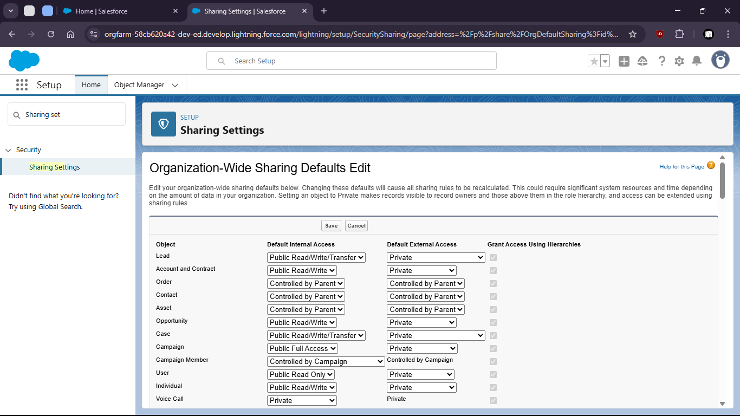
10. Now goto home > Roles
12. 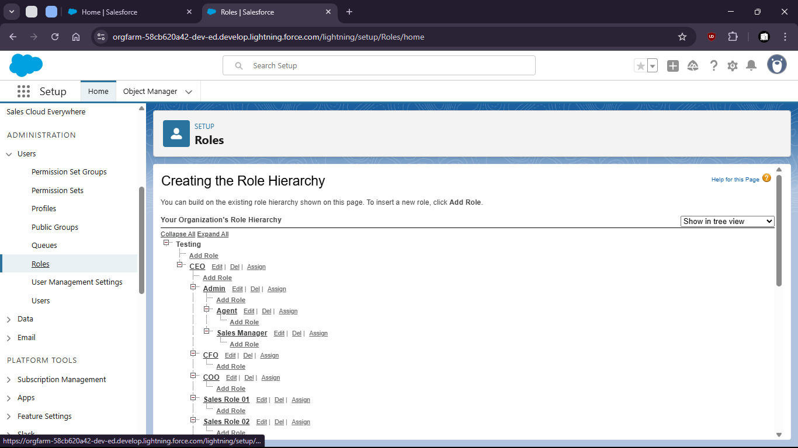
14. Set up roles under CEO as Admin
16. 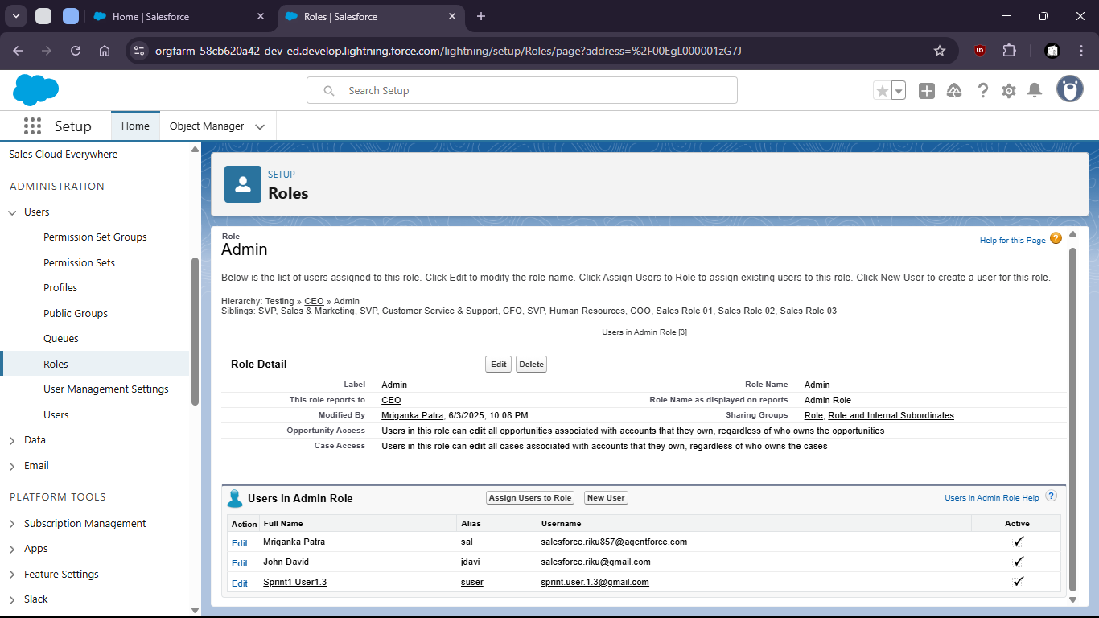
18. Look for assigned users to this role
20. 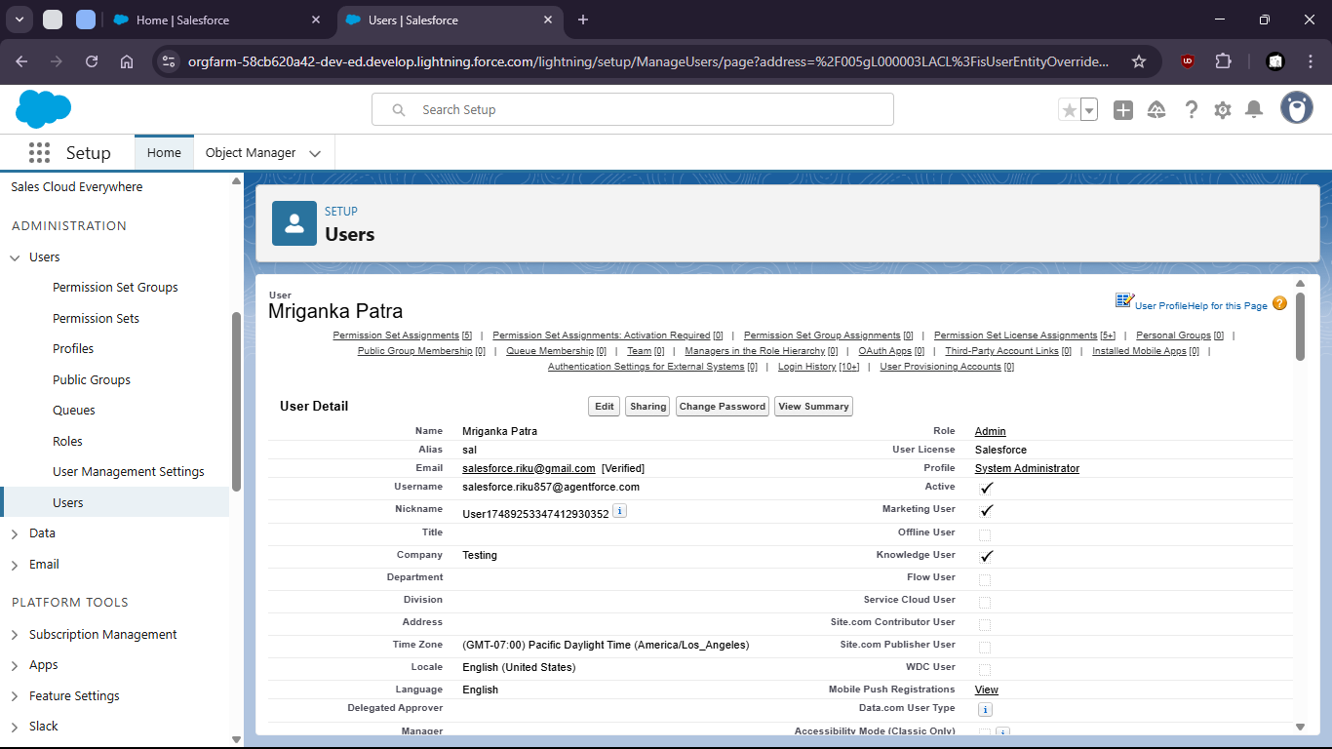
22. For the assigned users in that Role create a sharing rule
24. 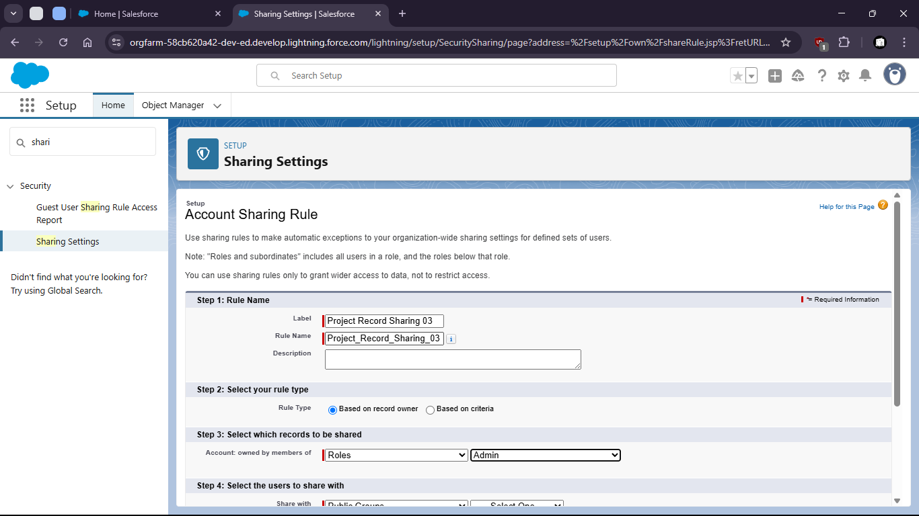
26. 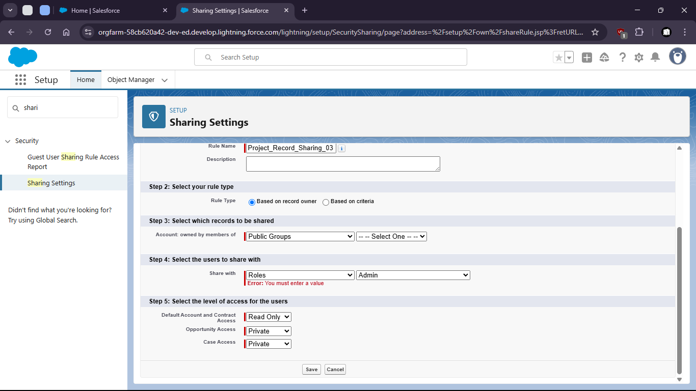
27. 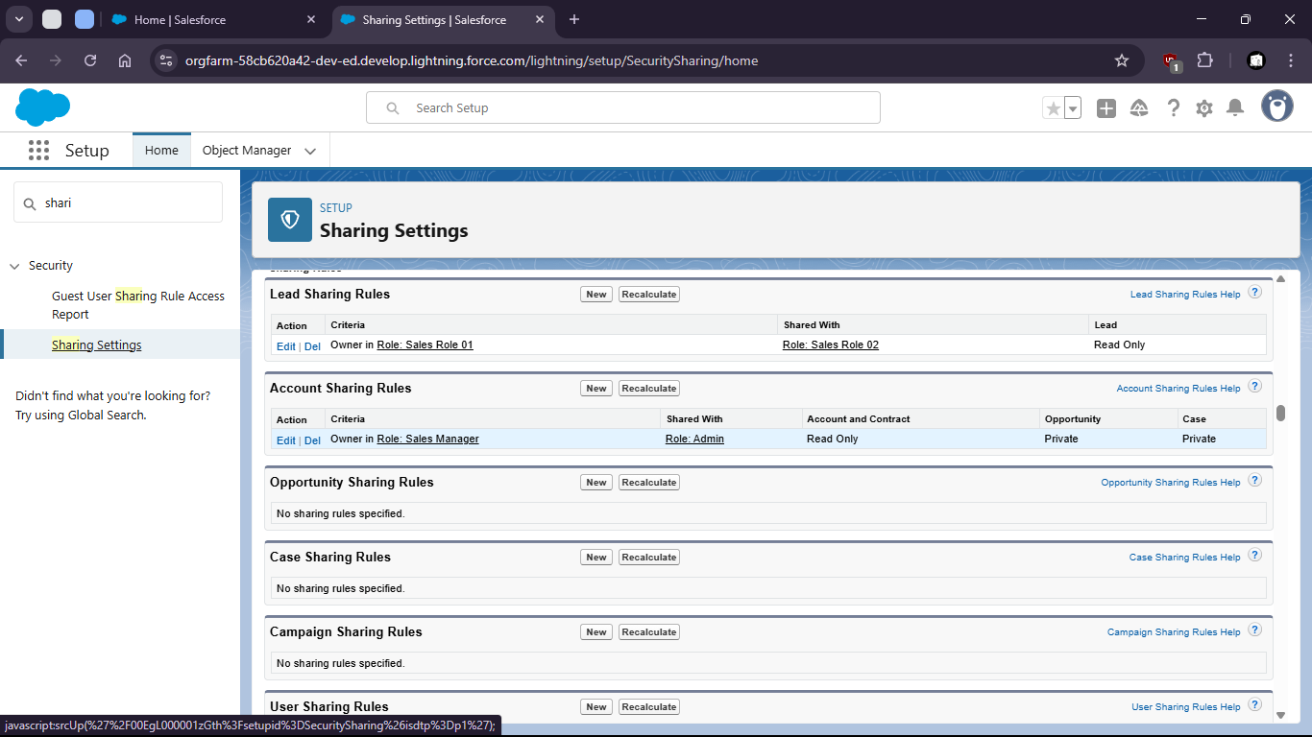

Task 1.5: As a data manager, I want to bulk upload Account records using the data loader so that initial data can be seeded efficiently.

1. Go to setup > home
2. 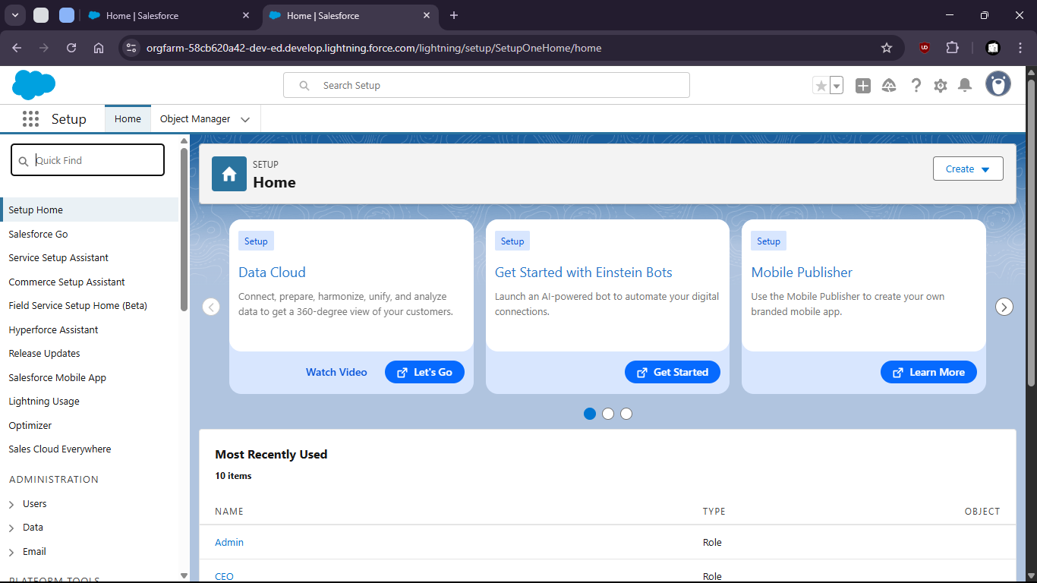
4. Search for data import wizard

7. 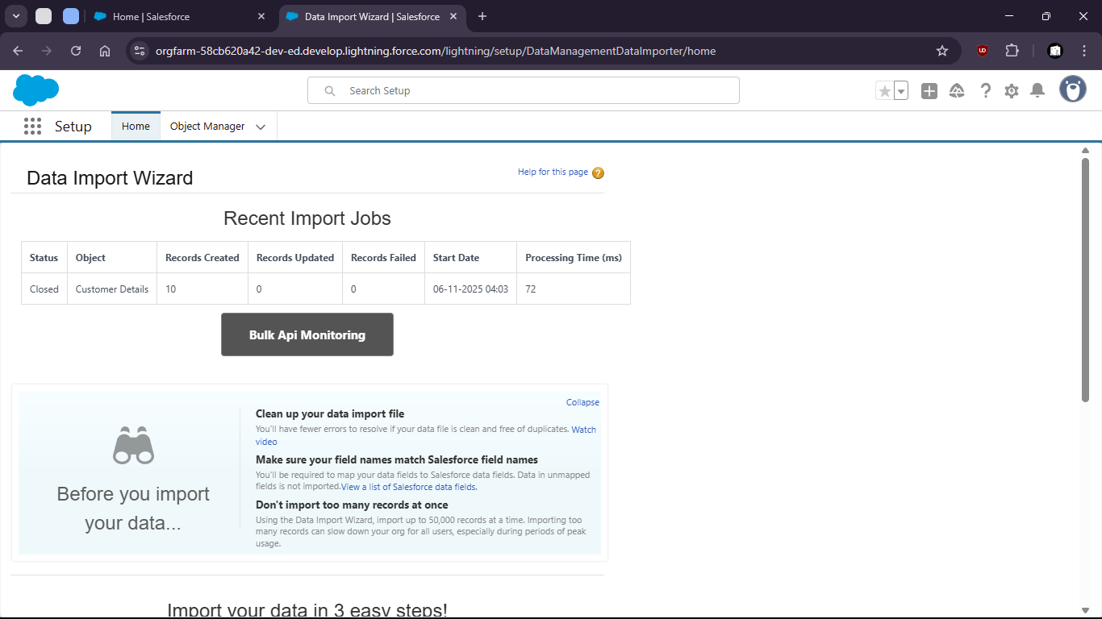

10. launch wizard

13. 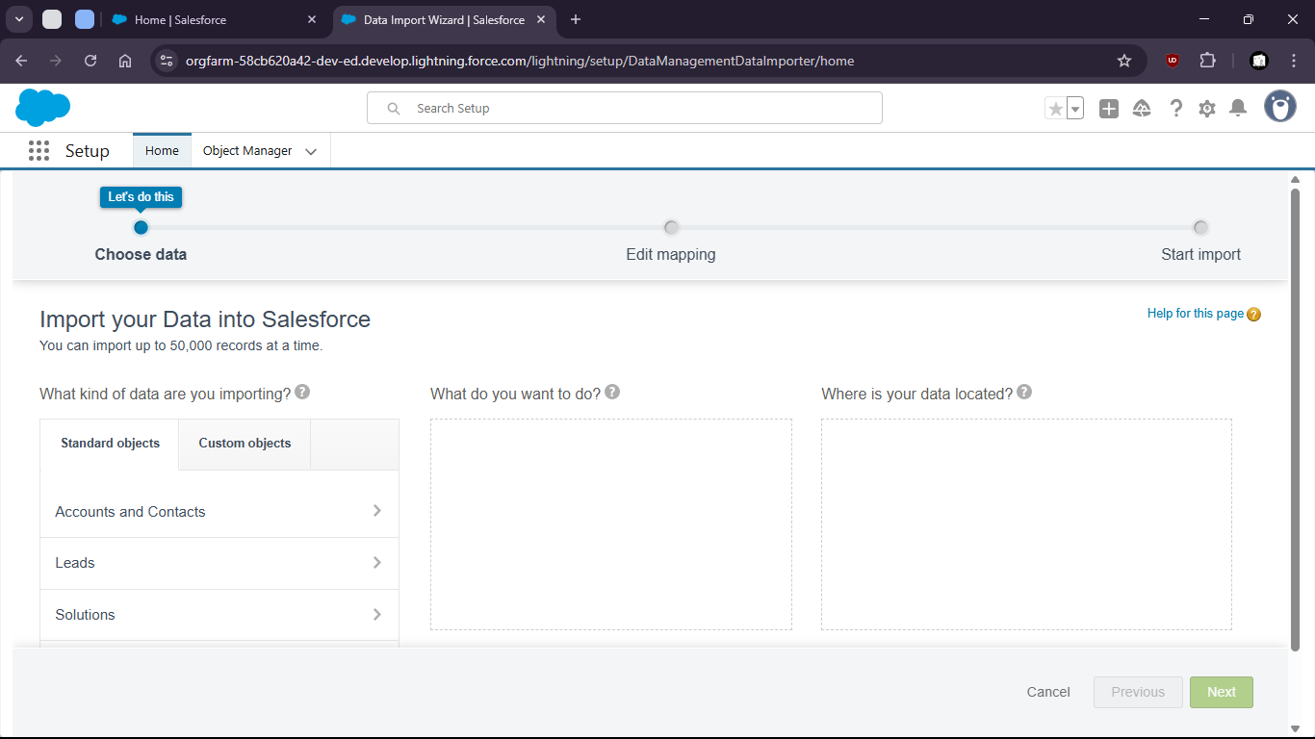

16. Select > Custom object > Customer Details > Add new Records > Upload the csv
18. 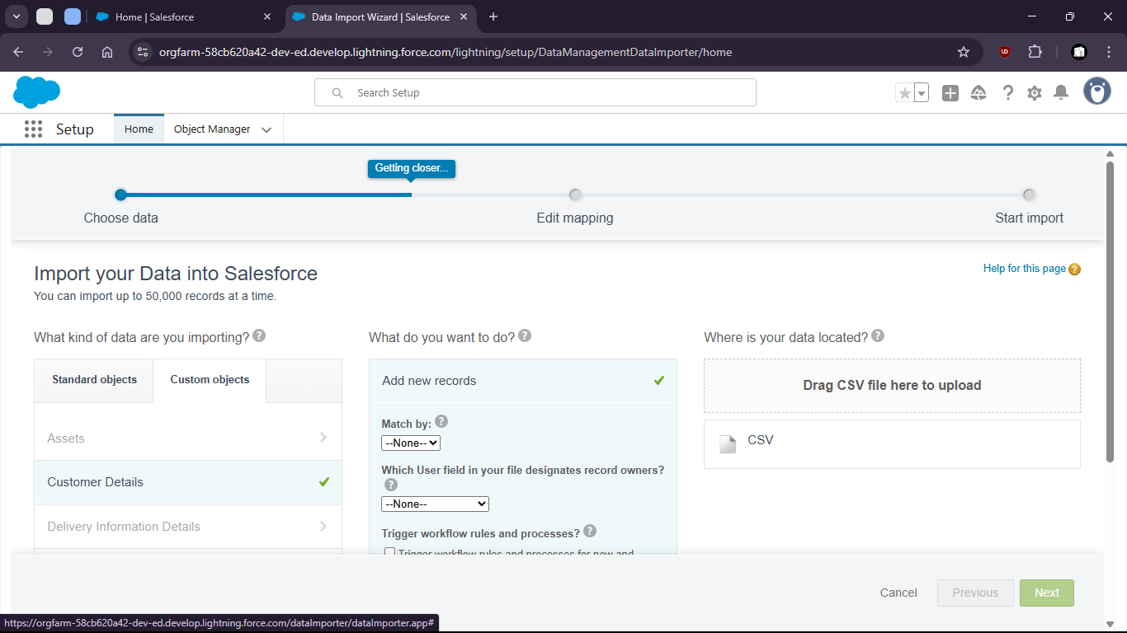
20. 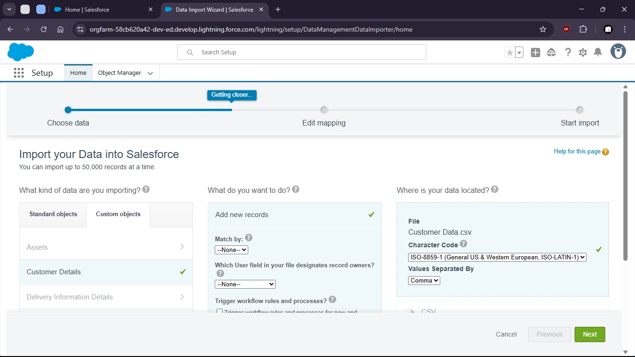

23. 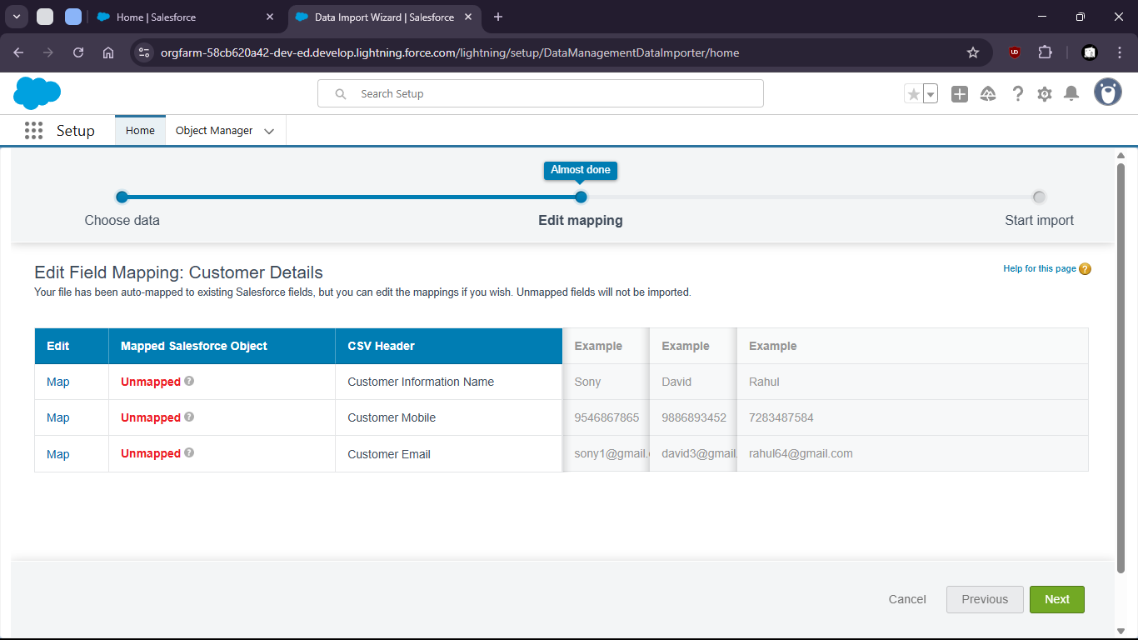
24. Now map the fields
26. 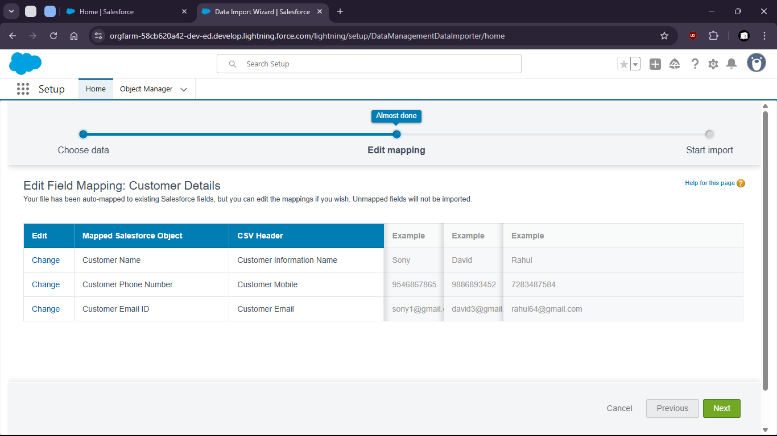
28. now start import
29. 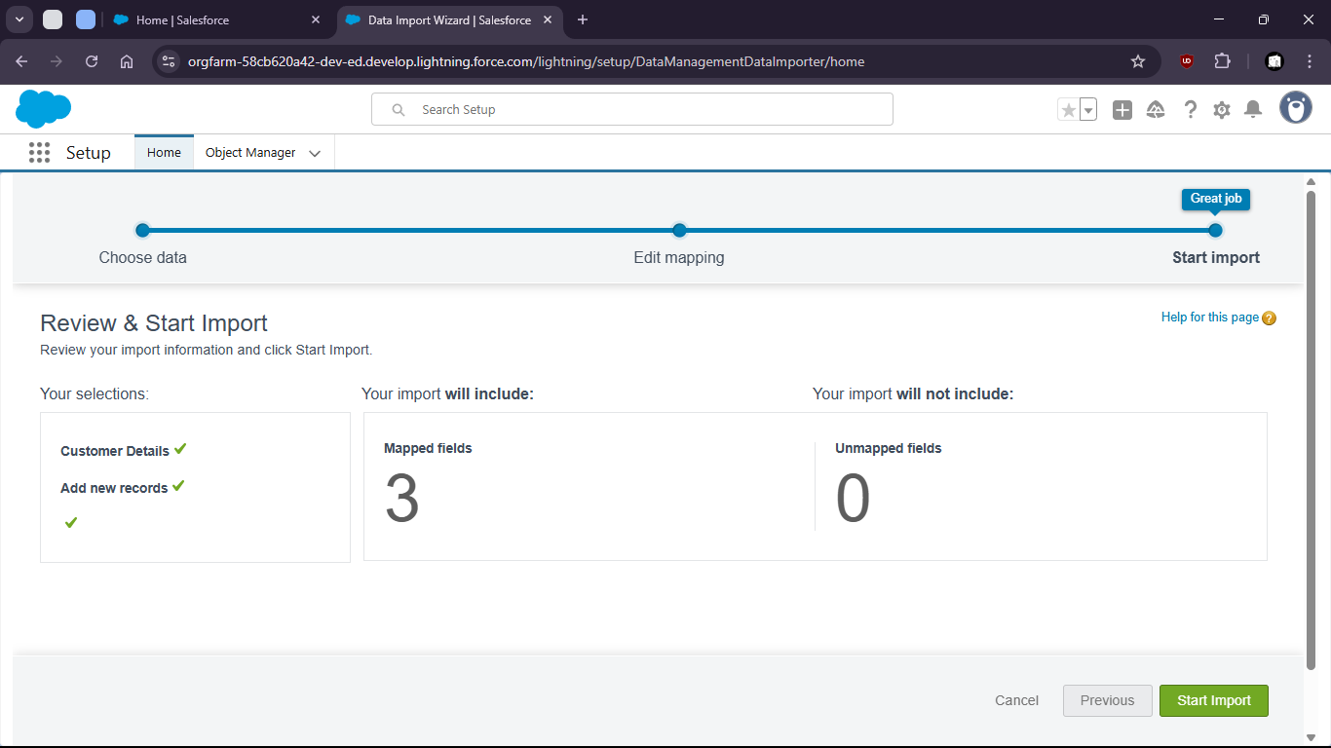

32. 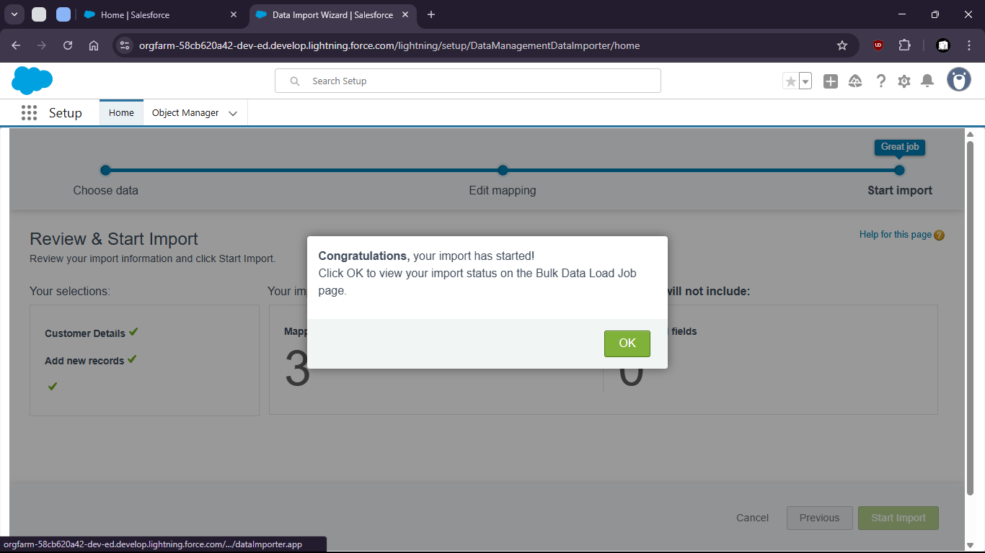

35. 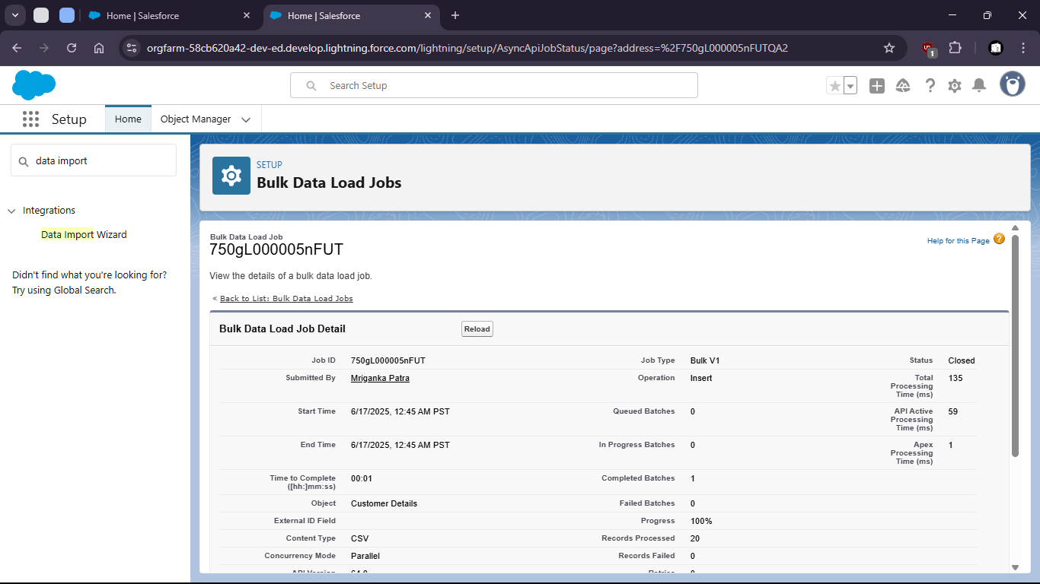

38. Now check for all customer details (if upload was successful)

41. 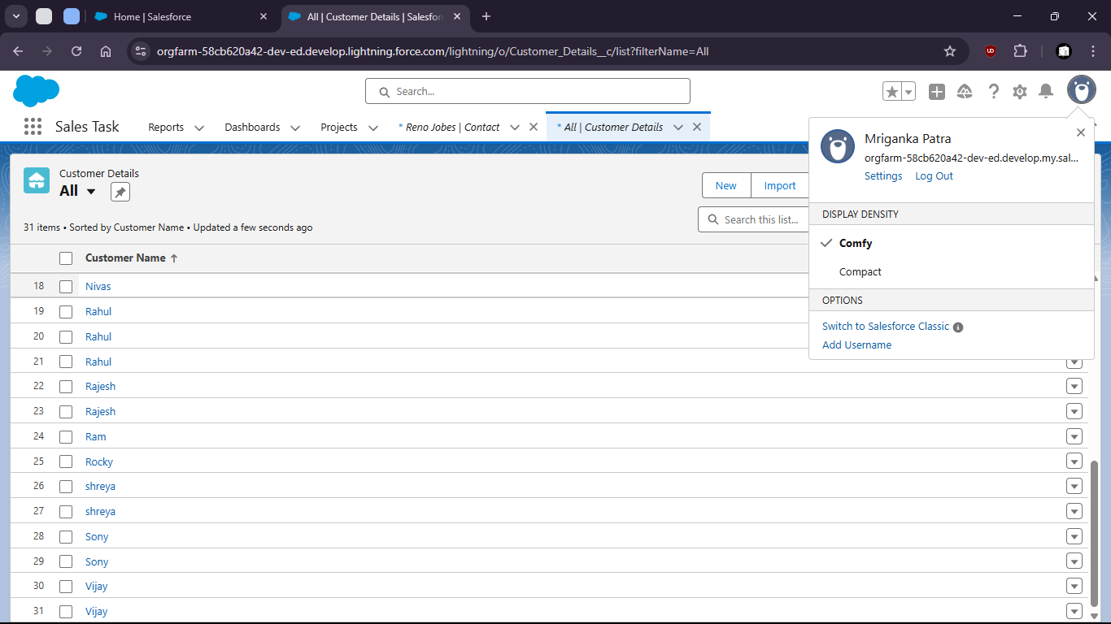
42. Uploaded csv file:
44. 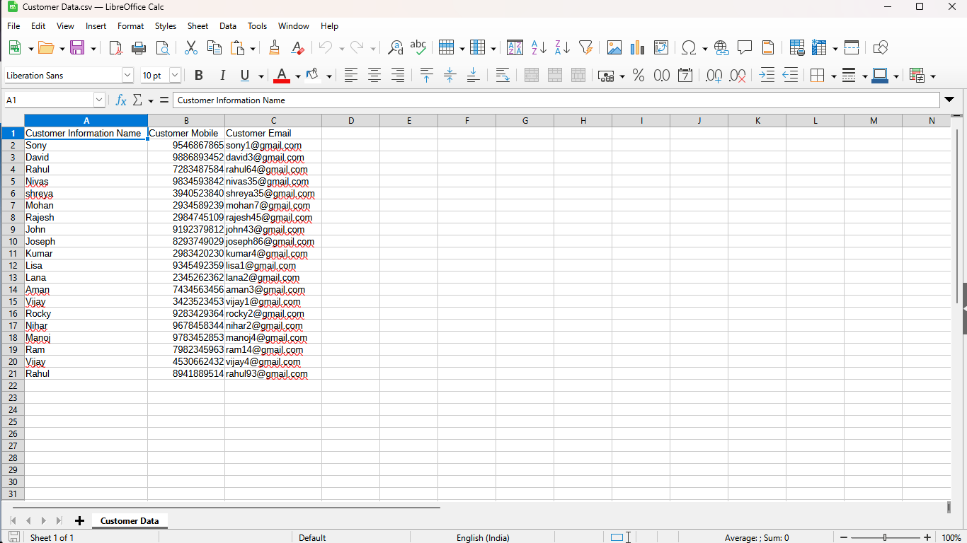
46. Validations

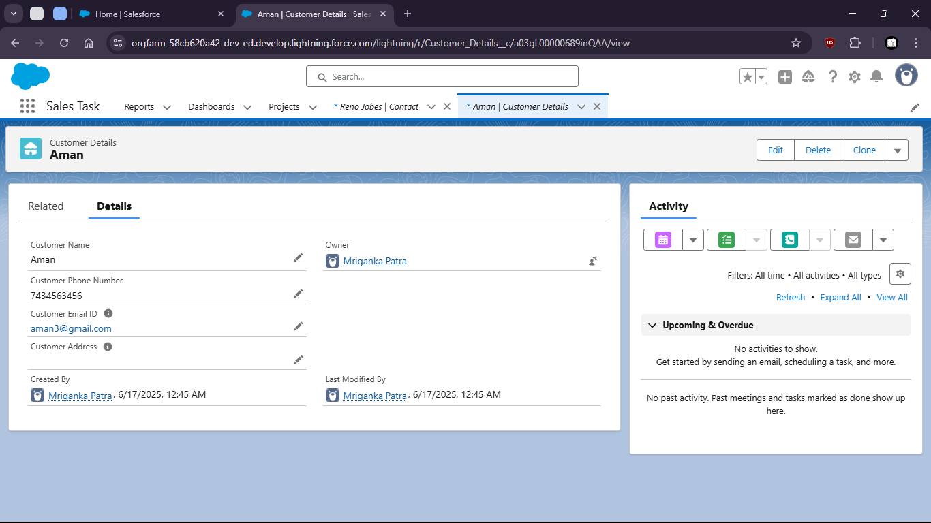

Task 1.6: As a sales manager, I want to auto-create an opportunity when a new Account is added so that sales tracking begins immediately.

1. Go to setup > Object Manager

4. 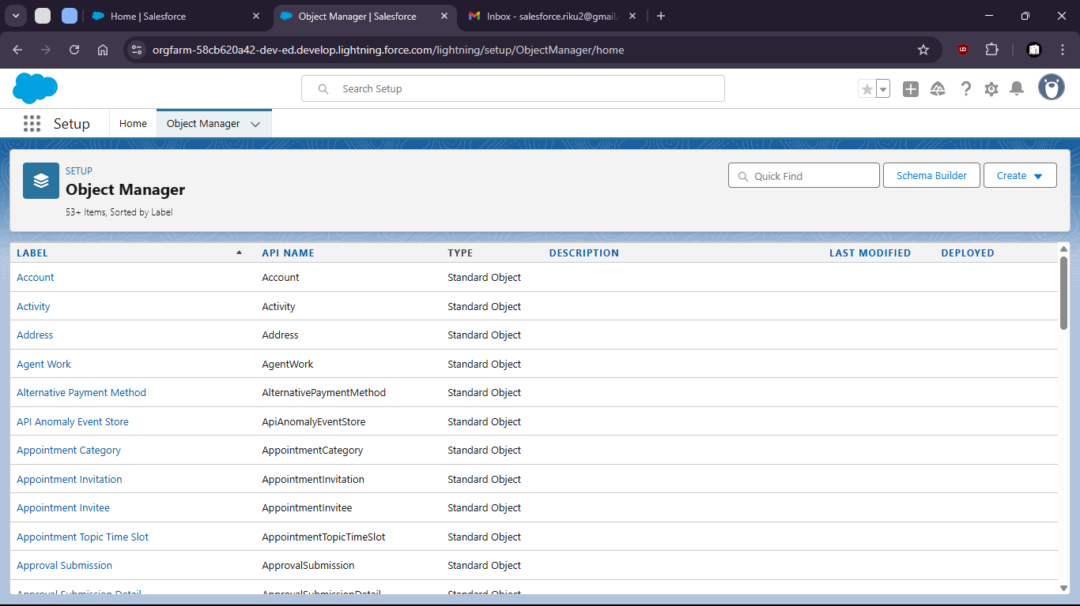
6. select opportunity

9. 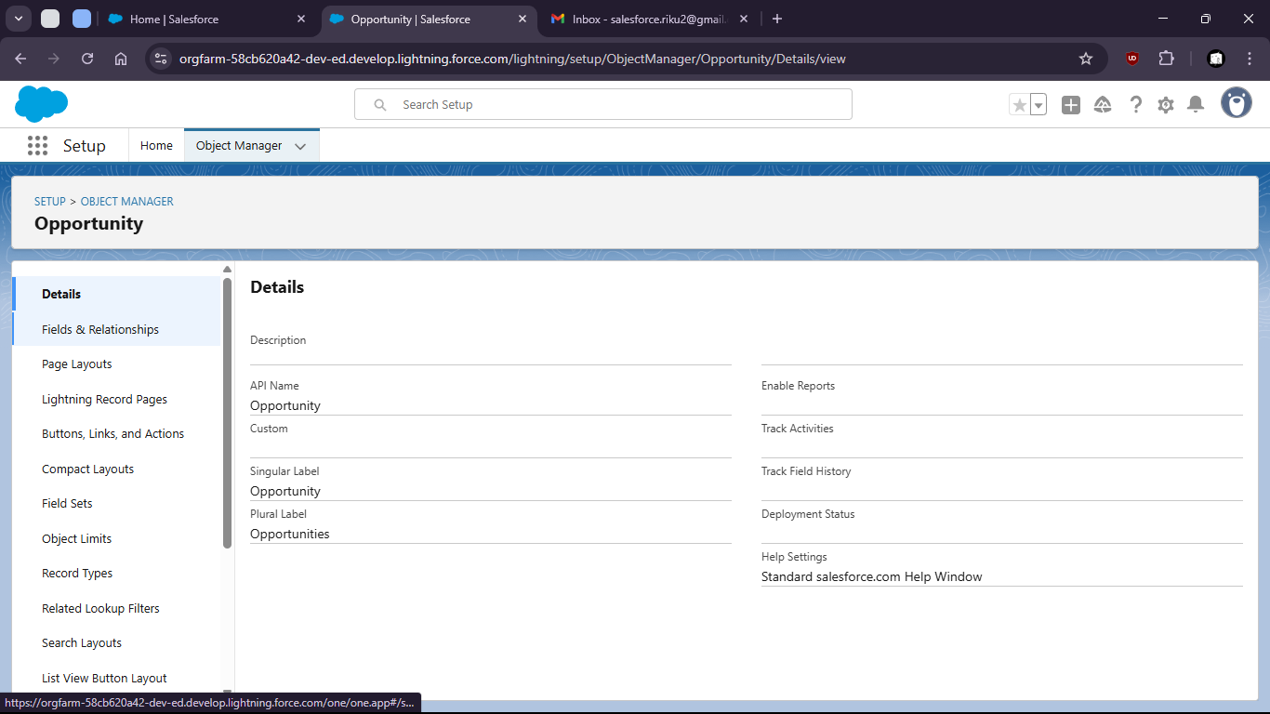
11. Go to fields and relationships
13. 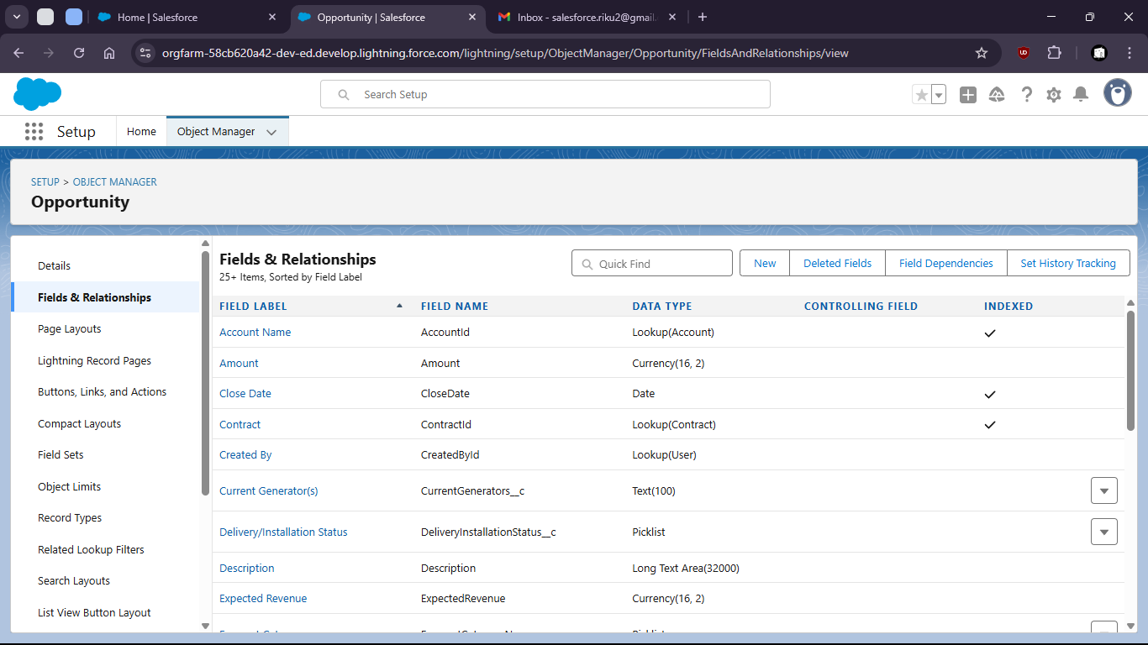

16. Create new Field “Region”

19. 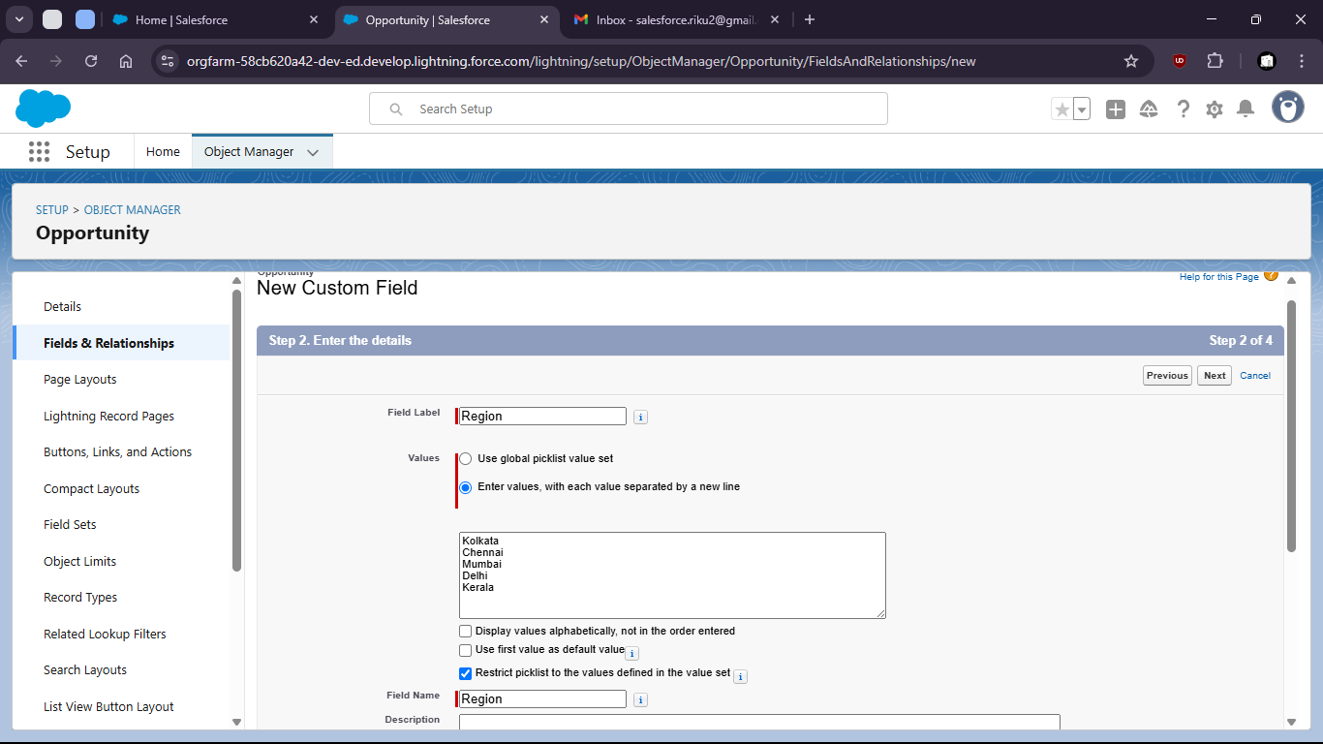

22. Now search For Reports in App Launcher

25. 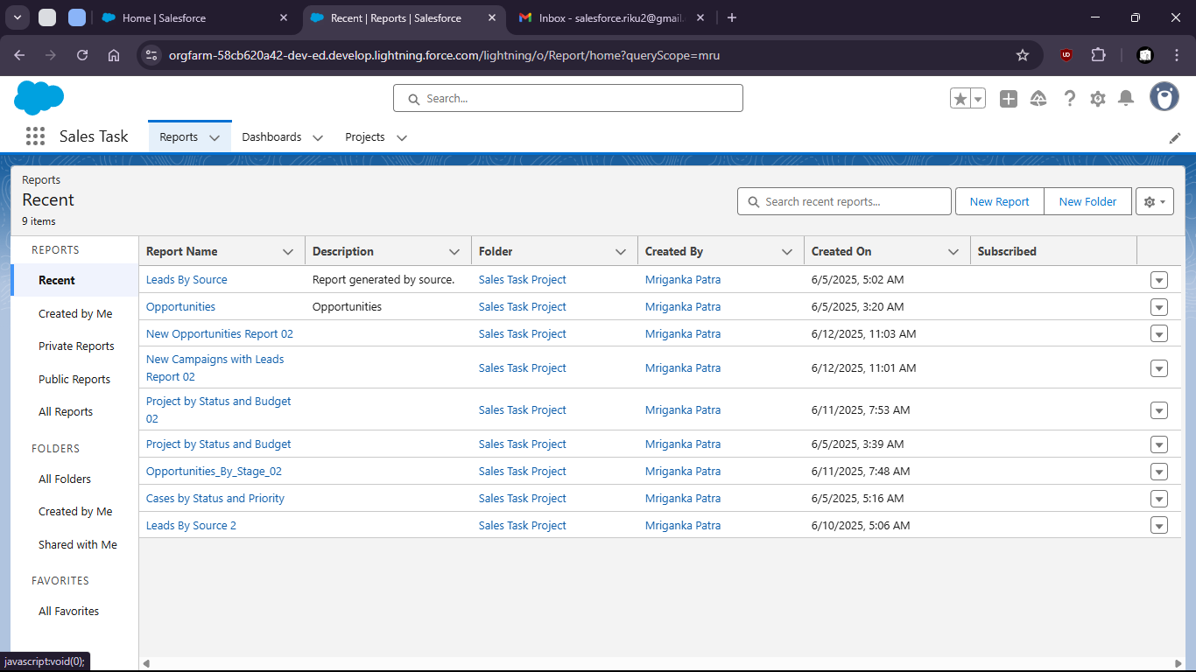

28. Create new report on Opportunities

31. 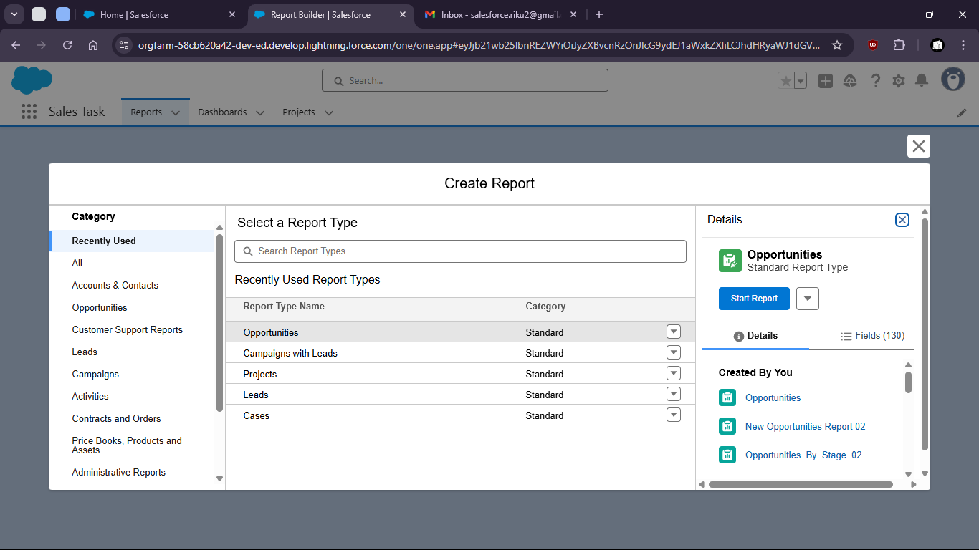

34. Group by region
36. 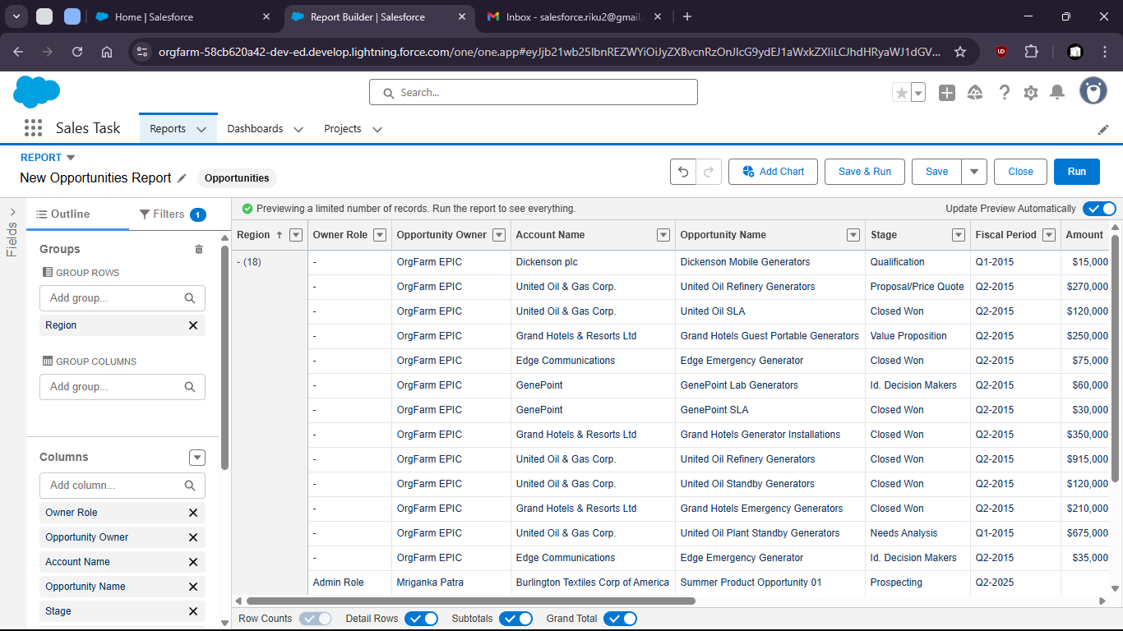

39. 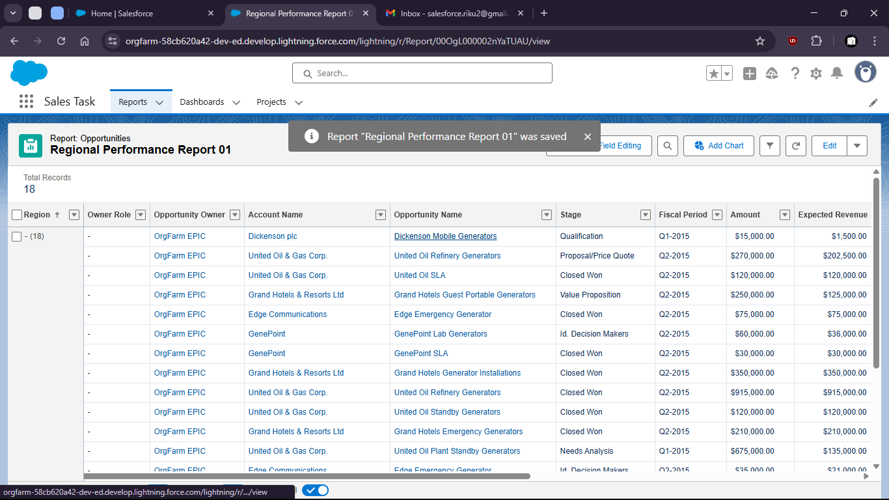

42. Create new Dashboard on the Report

45. 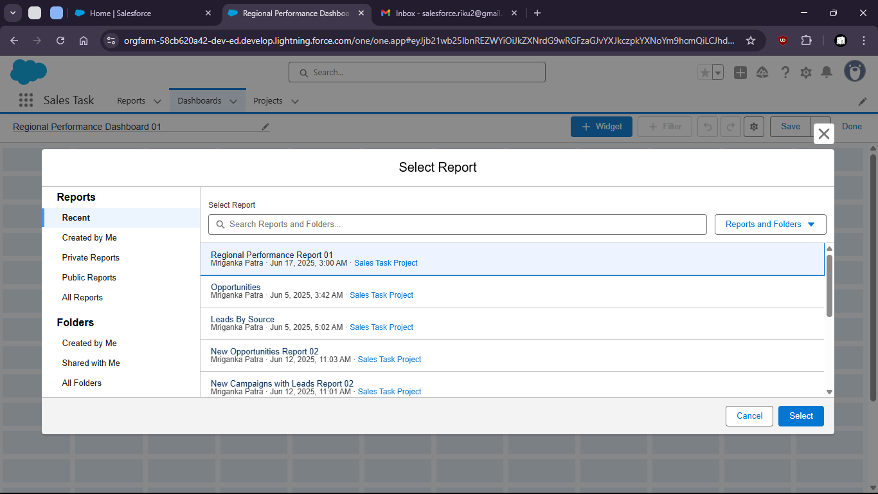
47. Add widgets for better visualization

50. 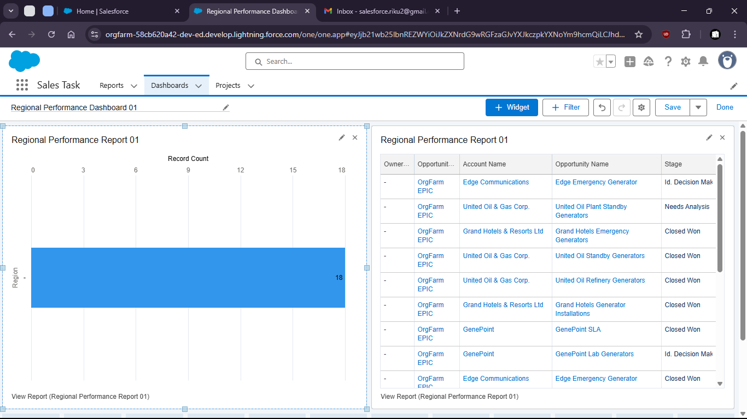

Task 1.7: As a system I want to auto-create an Opportunity when a new Account is added so that sales tracking begins immediately.

1. Go to Setup
3. 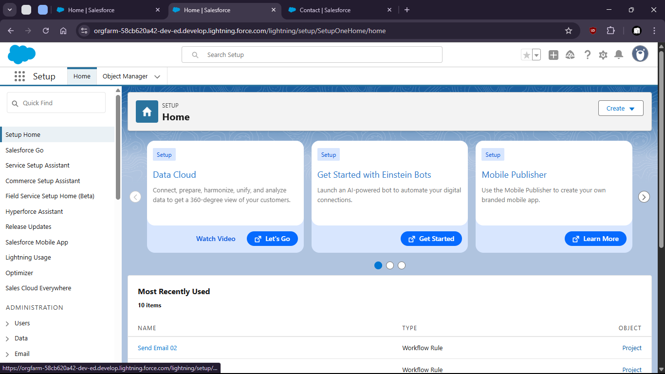
5. Search for “Flows”
7. 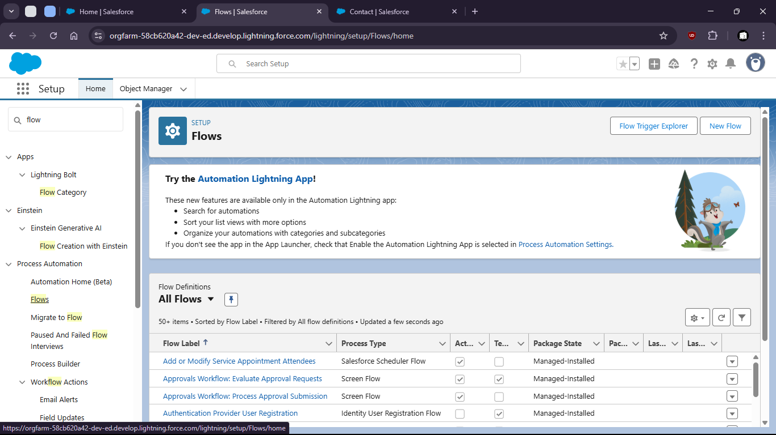
9. Click new
11. 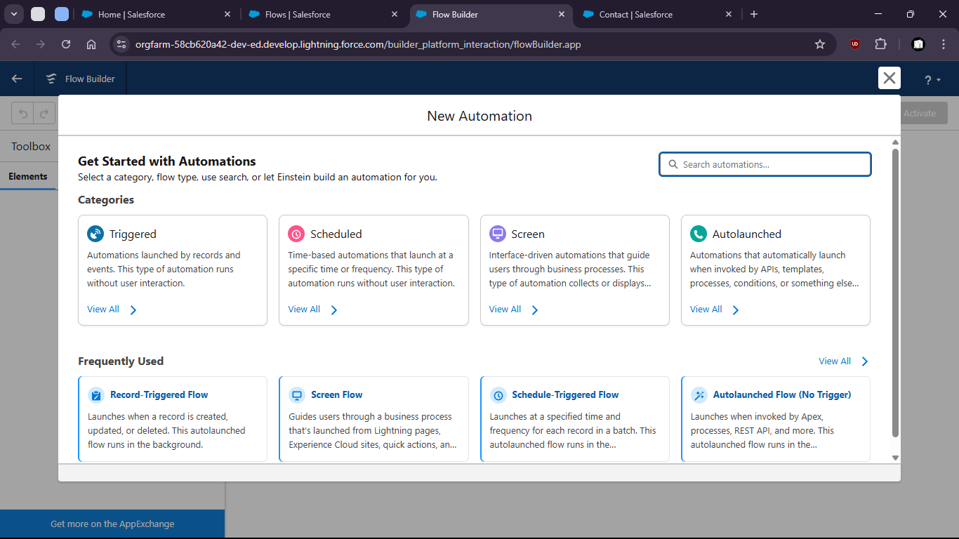
13. Select Record Triggered Flow
15. 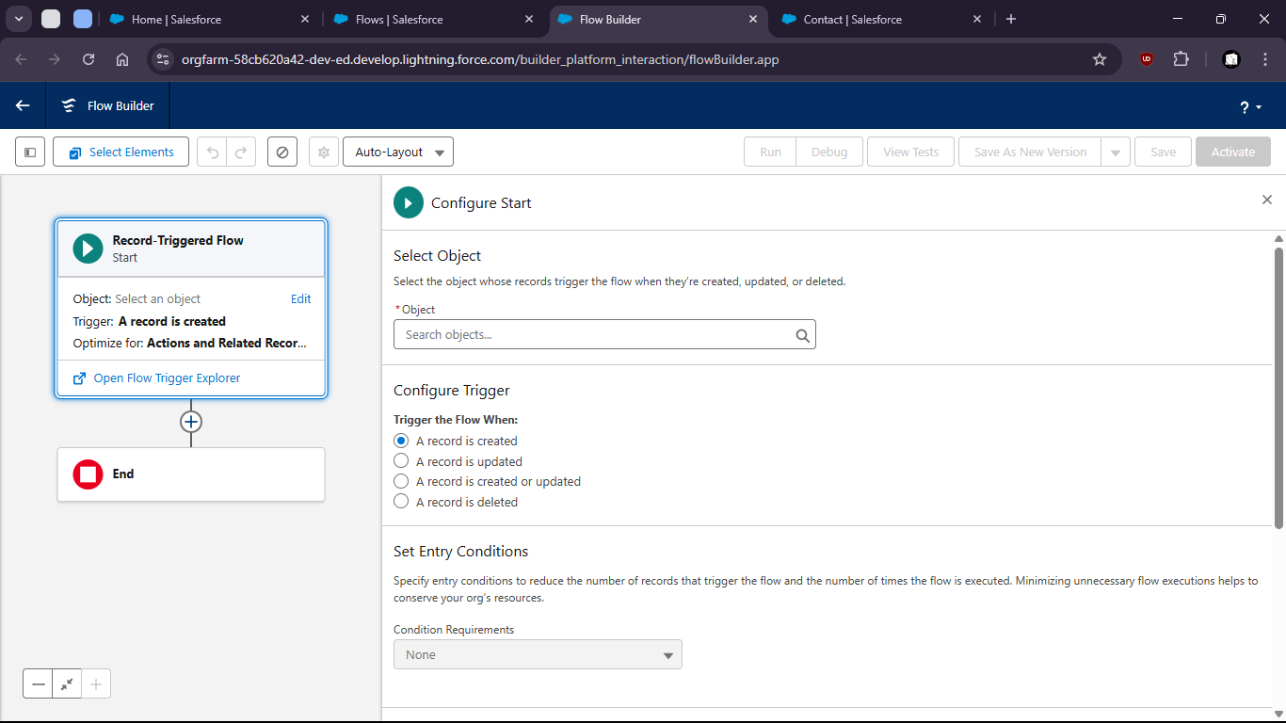
17. Select Account as Object

20. 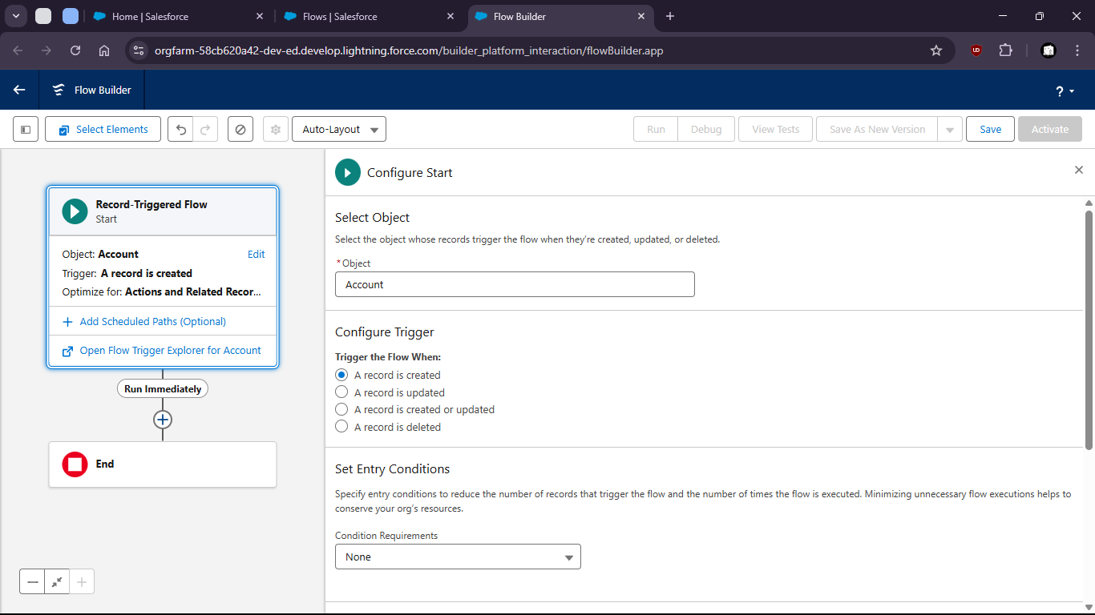

23. Add Create Records Element

26. 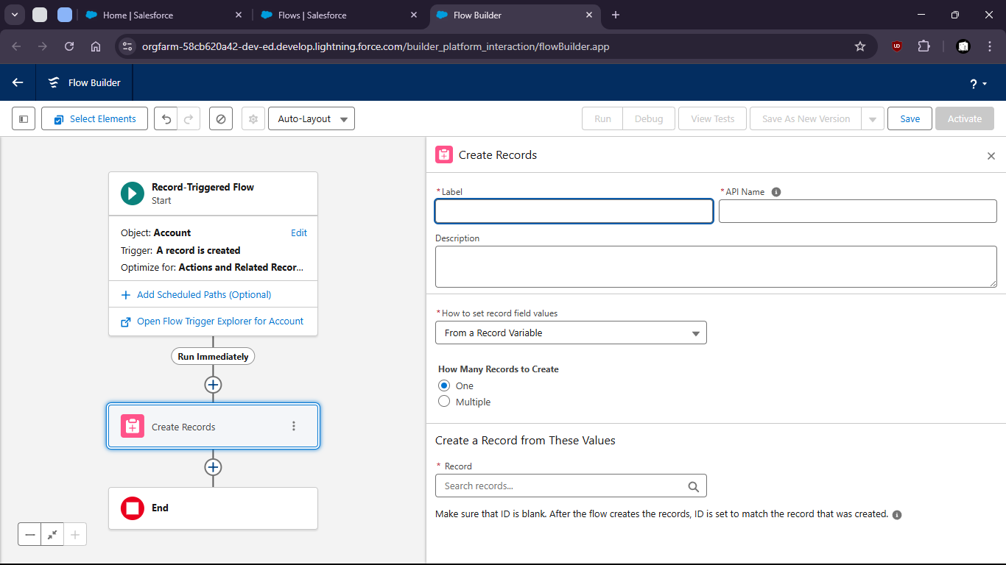


30. Fill Up opportunity field values

33. 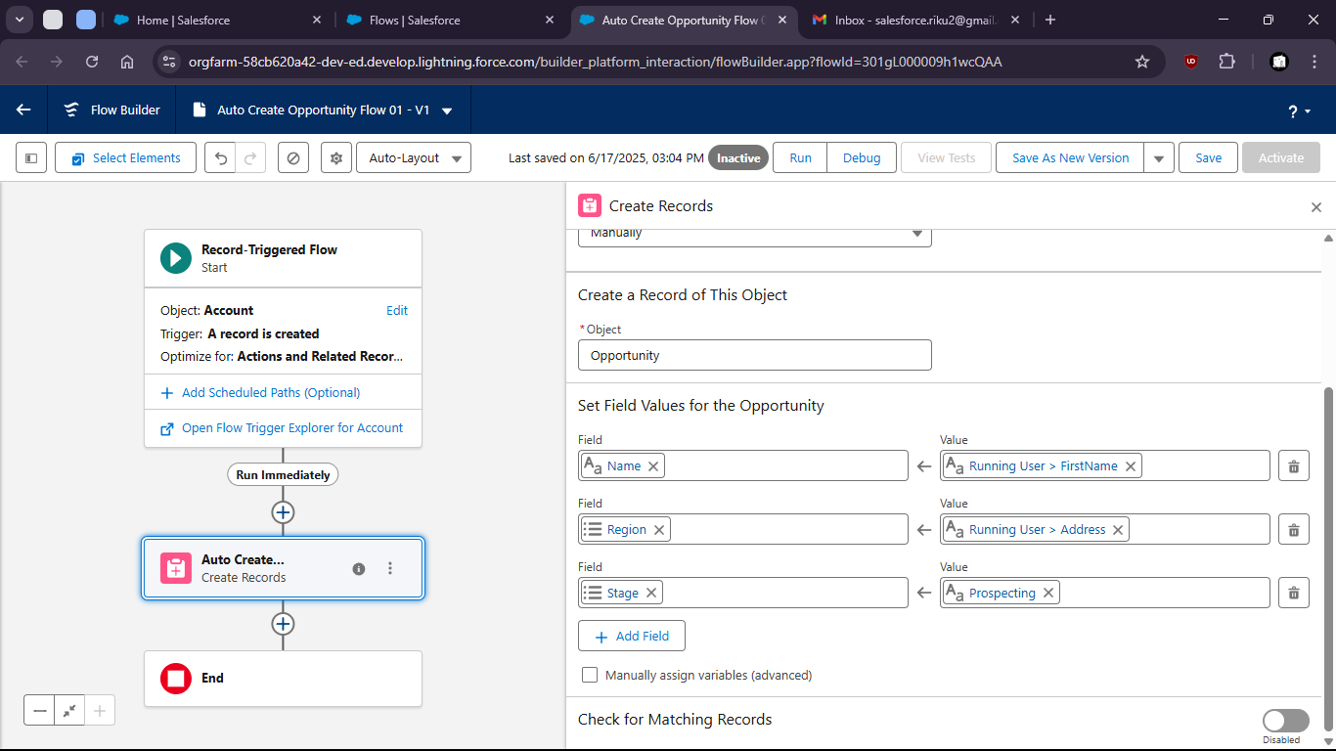

36. Save and Activate

39. 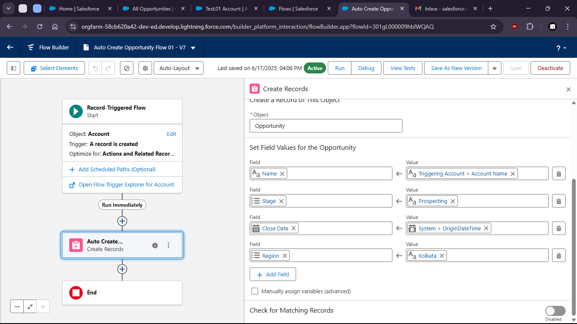

42. Now to verify
43. Crete a new Account (name: Test Account)
45. 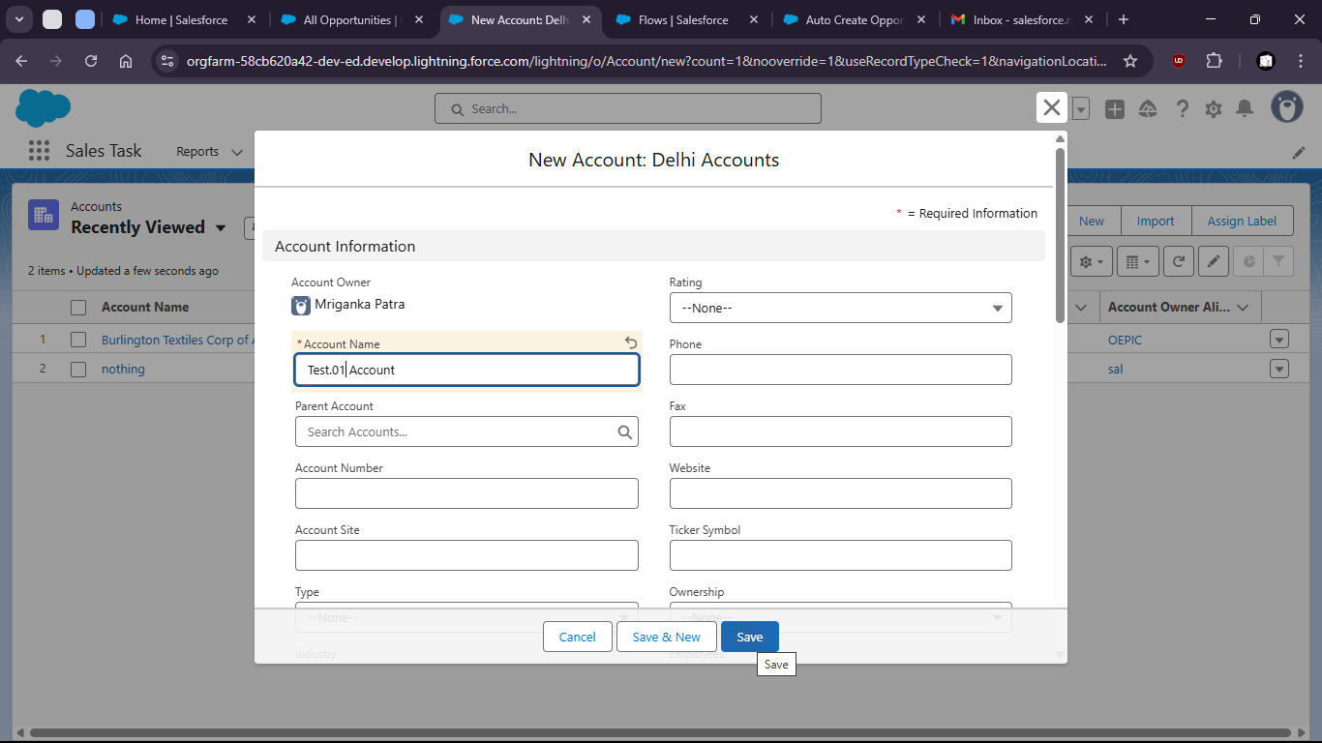

48. 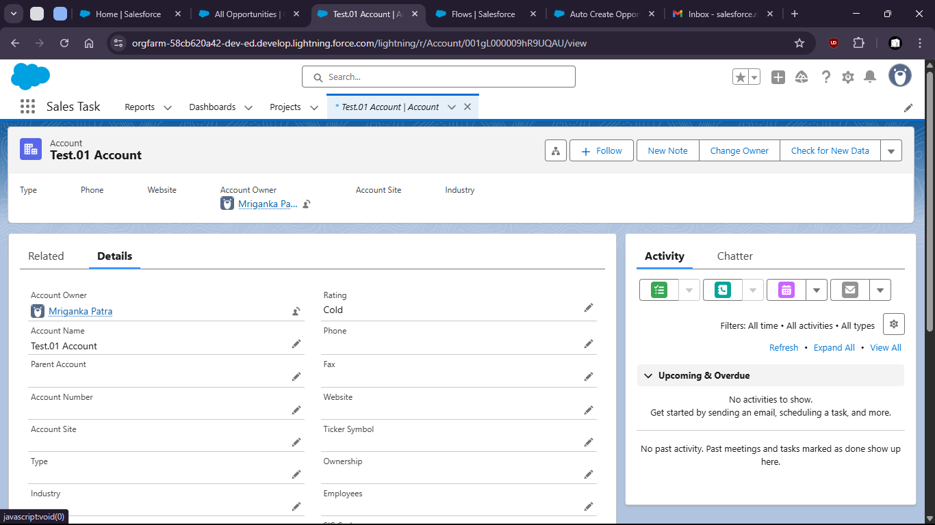
50. We can check new opportunity was created

53. 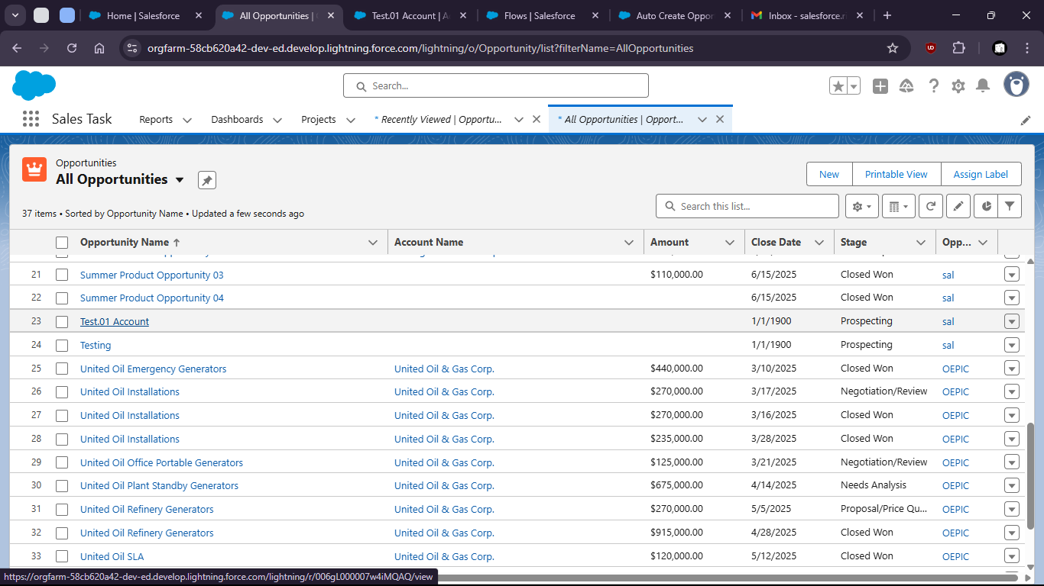

56. 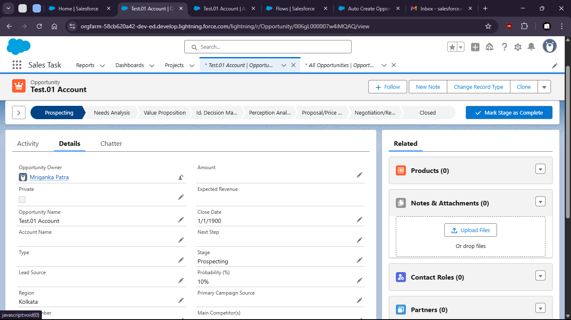

Task 1.8: As a System, I want to update fields based on predefined conditions to ensure data consistency.

1. Go to setup page > Home > workflow rules

4. 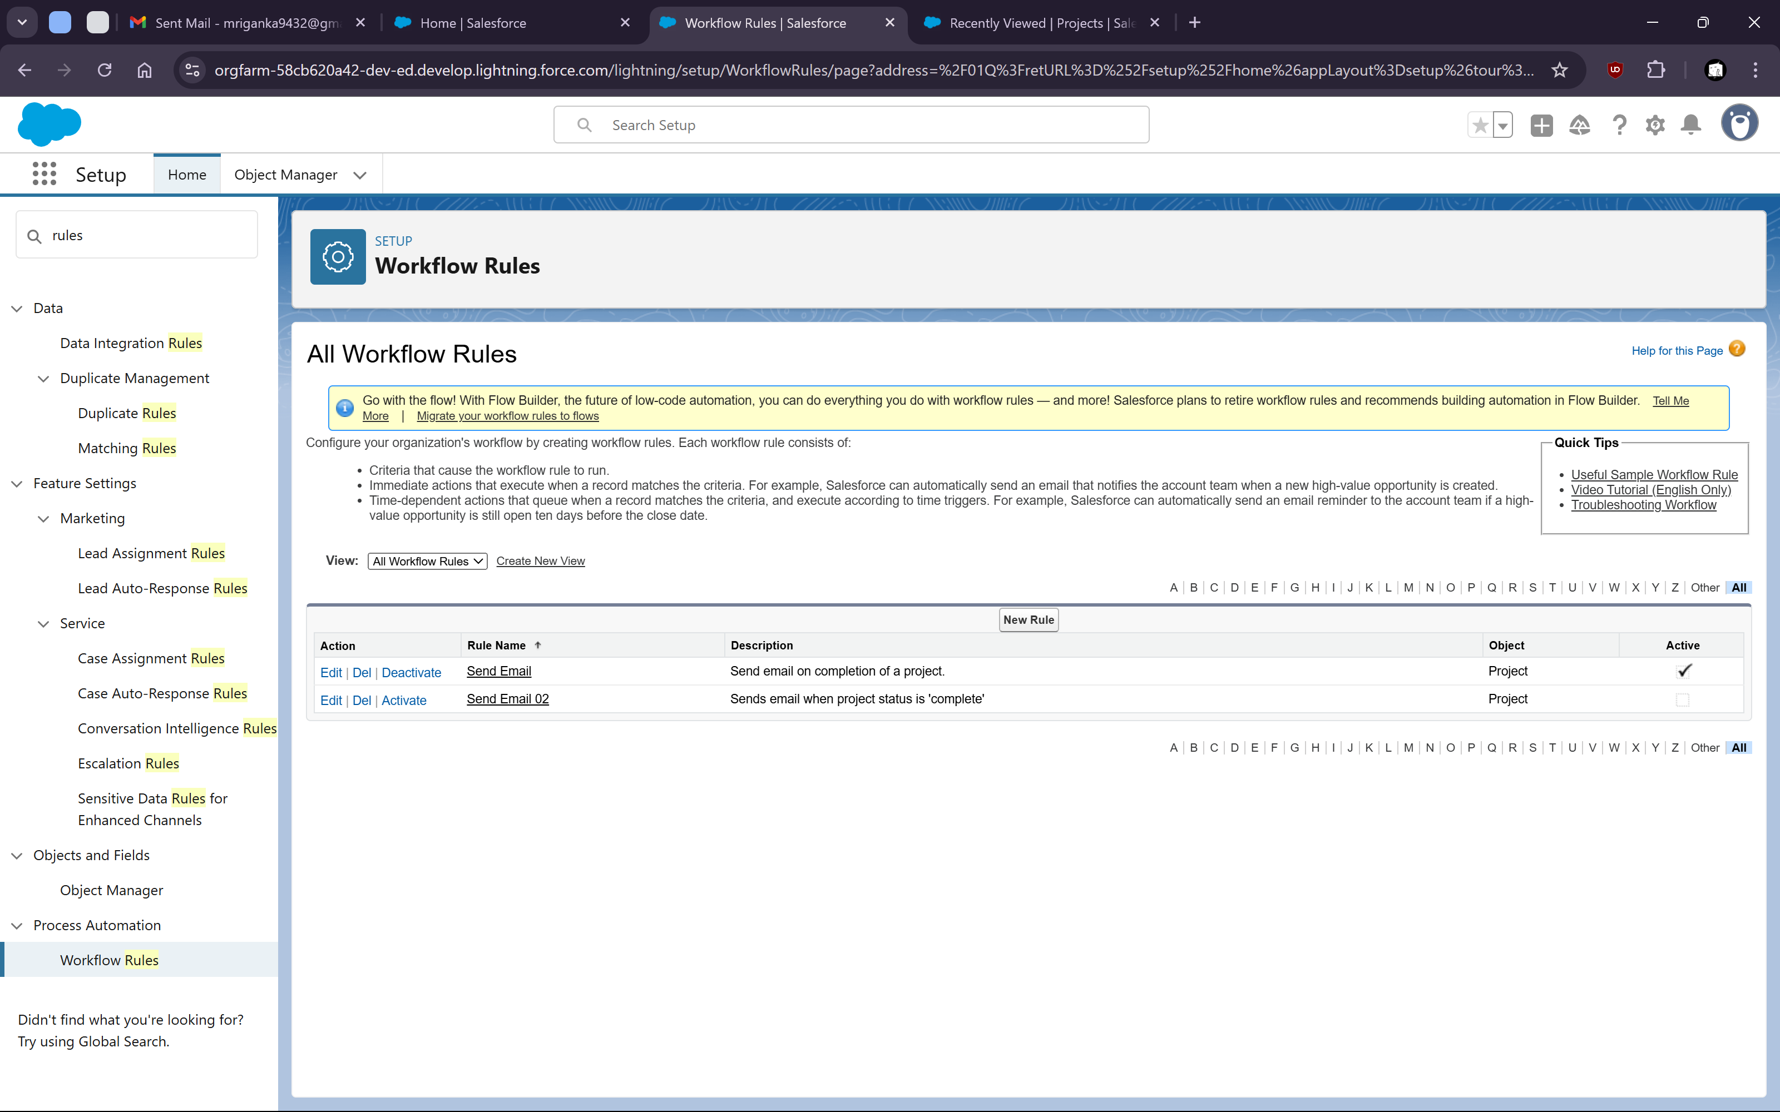

7. Create Rule with Project Object


11. 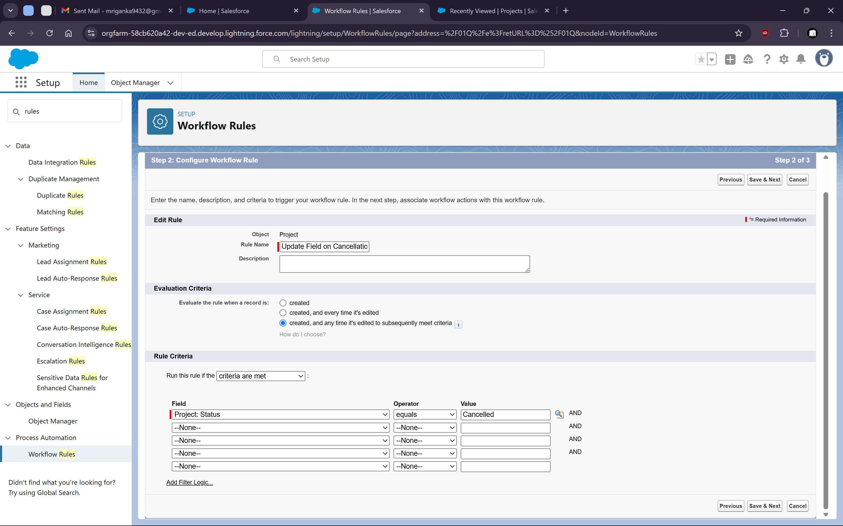

14. Setup Blank Value if Project Is Cancelled


18. 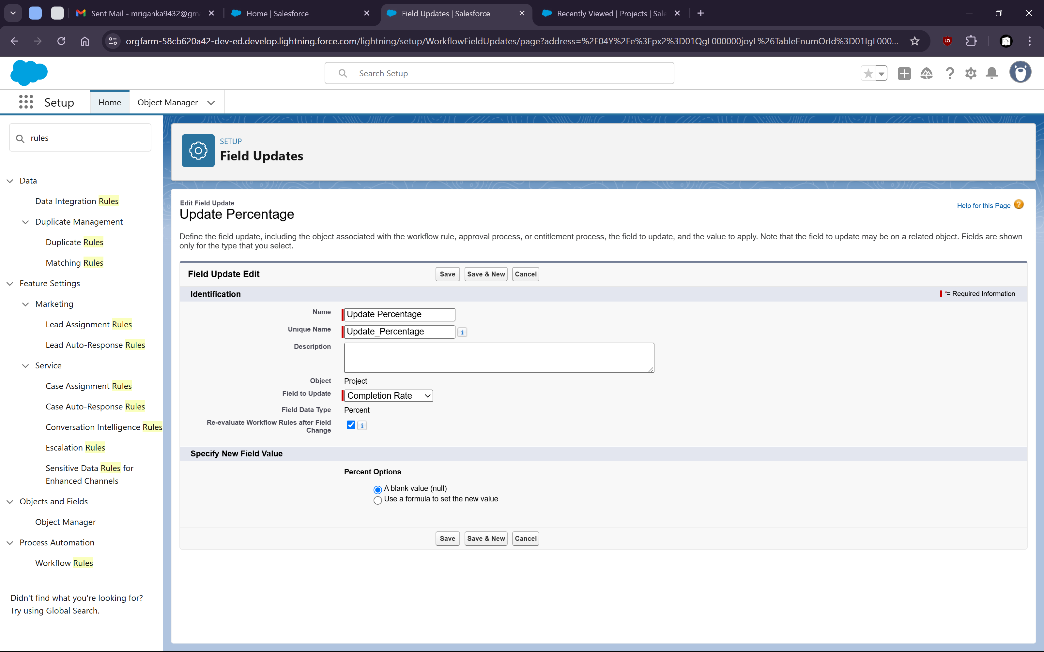

xiv. Now Activate the rule

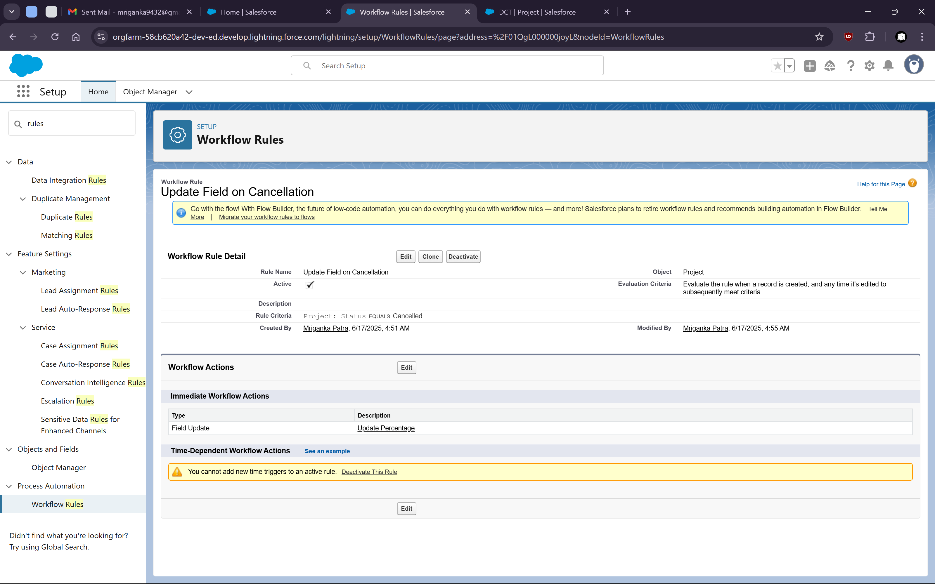

Xv. Now check if the rule is working or not

Go to one of the project where status is anything other than cancelled and the progress has a value

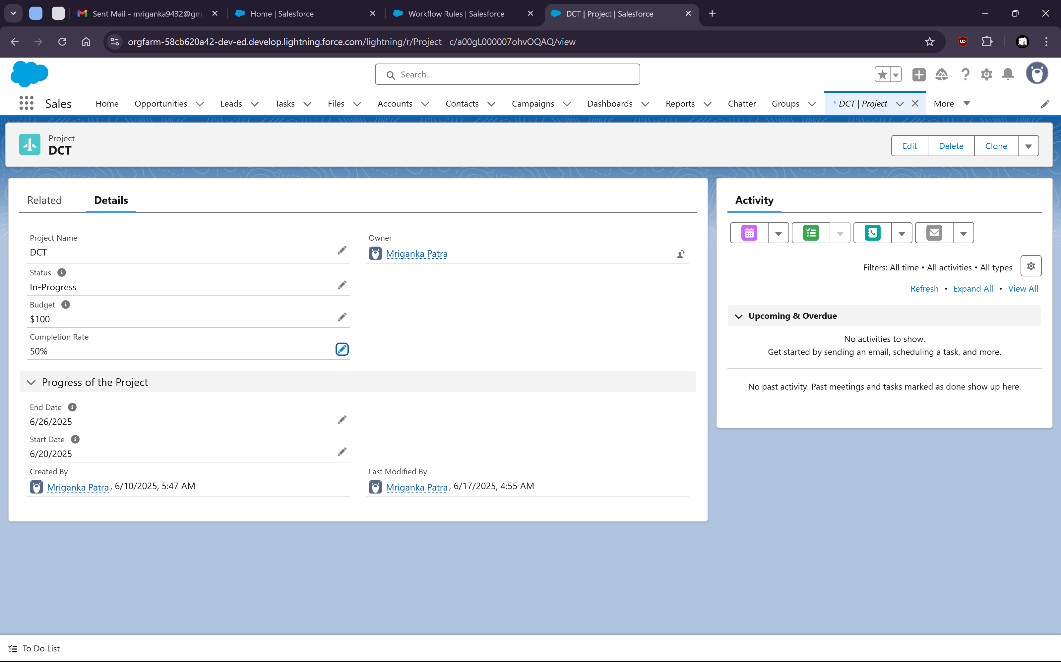

Now change the status to “Cancelled” and save it

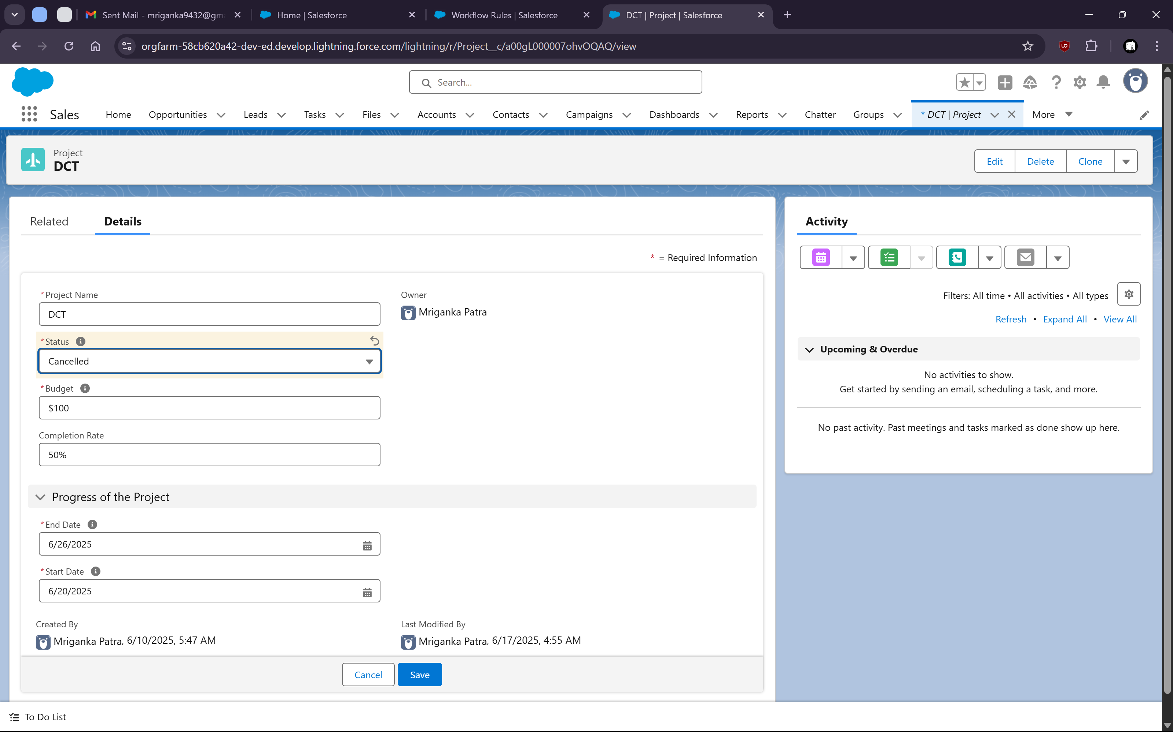

We can check that the completion rate gets set to NULL value after that

